High School
Yearly Examination
2014
Year 10
Advanced
Mathematics Course
General Instructions  - Reading time: 5 minutes  - Working time: 2 hours  - There will be a short break between Section 1 and Section 2  - Write using black or blue pen  - You may use a pencil to draw or complete diagrams  - Attempt ALL questions  - Approved calculators may be used in Section 2.  - Write your Name and Teacher’s Name in the spaces provided.  - A formula Sheet is on the reverse of this page and can be detached and used in all sections of the test. | Total Marks – 100  Section 1  Non Calculator Section.  25 marks  Time allowed for this section is 30 minutes.  Write all answers in the spaces provided.  Section 2  Time allowed for this section is 1 hour and 30 minutes.  Part A  Multiple Choice Section.  Mark your answers on the separate answer sheet at the end of the examination.  50 marks  Part B  Longer Answer Section.  Write all answers in the spaces provided.  25 marks

Formula Sheet
Pythagoras’ Theorem
c = hypotenuse
a and b are the shorter sides

Circumference of a circle
d = diameter

Area of a circle
r = radius

Area of a parallelogram
b = base
h = perpendicular height

Area of a rhombus or kite
x and y are the diagonals

Area of a trapezium
h = perpendicular height
a and b are the parallel sides

Volume of a prism
A = area of base
h = perpendicular height

Volume of a pyramid
A = area of base
h = perpendicular height

Volume of a cylinder
r = radius
h = perpendicular height

Volume of a cone

Volume of a sphere
Surface Area of a Cylinder

Surface Area of Cone
r = radius
l = slant height

Surface Area of a sphere

Trigonometric formulae for a triangle ABC.

Sine Rule

Cosine Rule
or
Area of a triangle
Simple interest
P = Principal
R = interest rate per time period as a decimal
T = number of time periods

Compound Interest
A = Final amount to which the investment grows
P = Principal
r = interest rate per compounding period as a decimal
n = number of compounding periods
Depreciation
SV = Salvage Value to which the initial value falls
IV = Initial Value
r = depreciation rate per compounding period as a decimal
n = number of compounding periods

Gradient of a line
and are points on the line
m = gradient

Midpoint of a line segment

Length of a line segment
Equation of a line
or
b = y intercept

Yearly Examination
Advanced Mathematics

Class/Teacher ______________________

Name______________________

Section 1

25 marks
Time allowed for this section is 30 minutes

Answer Questions 1–25 in the spaces provided.

Calculators are NOT to be used in this section.

There will be a short break between Section 1 and Section 2.

Section 1 Non Calculator Section
 | Write all working and answers in the spaces provided on this test paper.
1. | 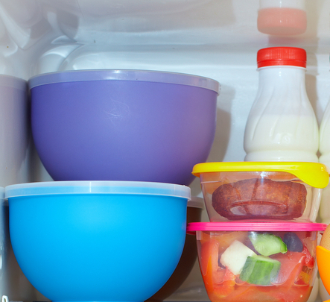Mitchell takes five containers from the fridge.  The temperatures of the containers are shown below.  3º C, -2º C, -6º C, 0º C and -15º C  Write the temperatures in increasing order.  ……….…………………………………………………  ………………………………………………………….
2. | 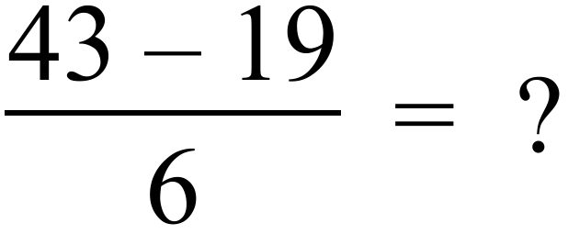  …………………………………………………………………………………………………………….  …………………………………………………………………………………………………………….
3. | 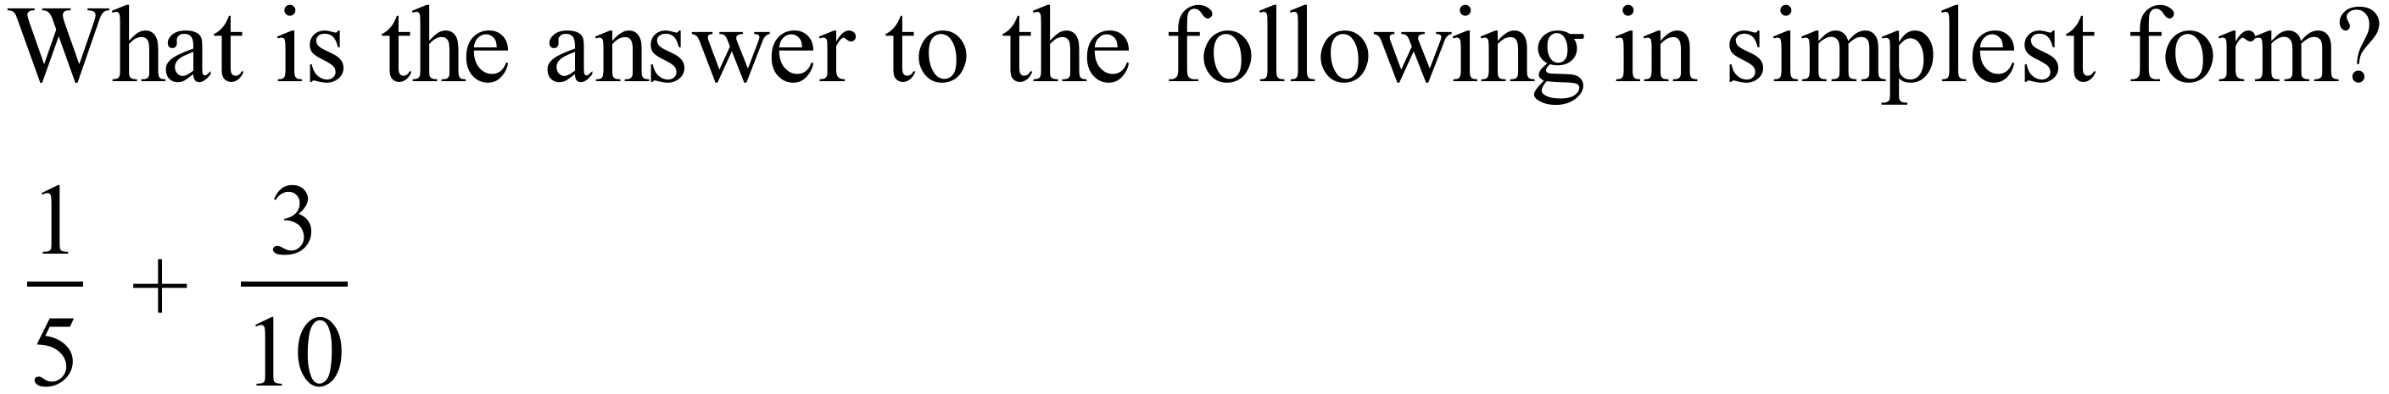  …………………………………………………………………………………………………………….  …………………………………………………………………………………………………………….
4. | 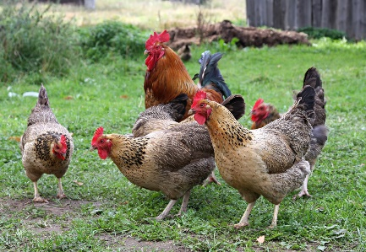Emilia finds that only 14 of her 40 hens are laying eggs.  What percentage of her hens are laying eggs?  ……………………………………………………………  ……………………………………………………………
5. | There are 30,000 males living in the town of Ammaville.  The ratio of males to females living in the town is 15 : 16.  How many females live in Ammaville?  …………………………………………………………………………………………………………….  …………………………………………………………………………………………………………….
6. | 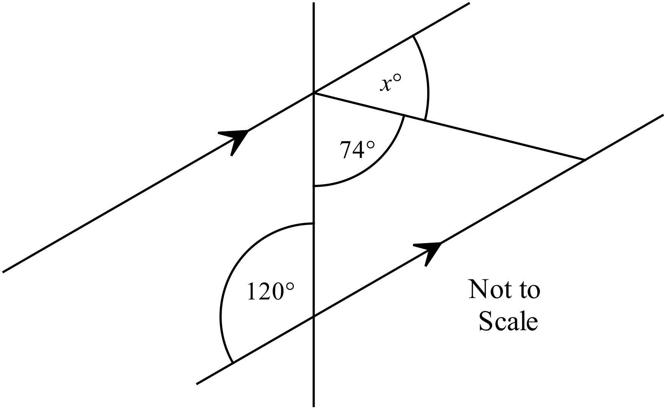Find the value of x in the diagram.  ……………………………………………………  .………………………………………………….  ……………………………………………………  …………………………………………………….
7. | A logo is to be created taking the design shown and adding an extra section which is a rotation through 180º of the design shown about the point C.  Complete the design of the logo. (Use geometric instruments.)  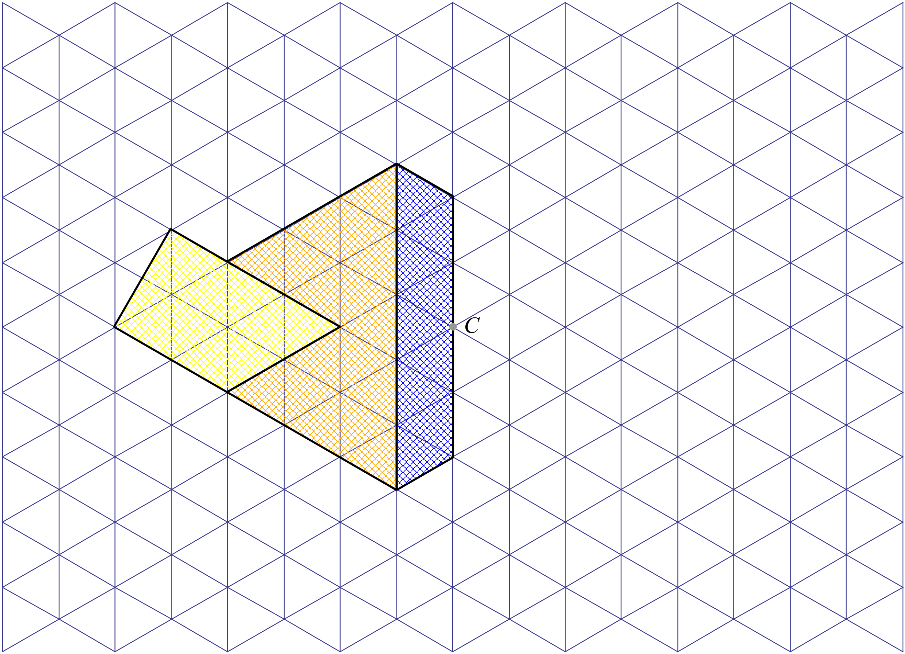
8. | Using the side AB shown, draw an accurate diagram of a rhombus ABCD with an internal angle of 60º at A. (Use geometric instruments including a protractor.)  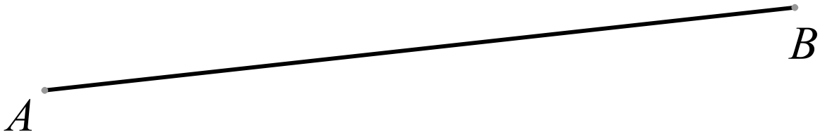
9. | 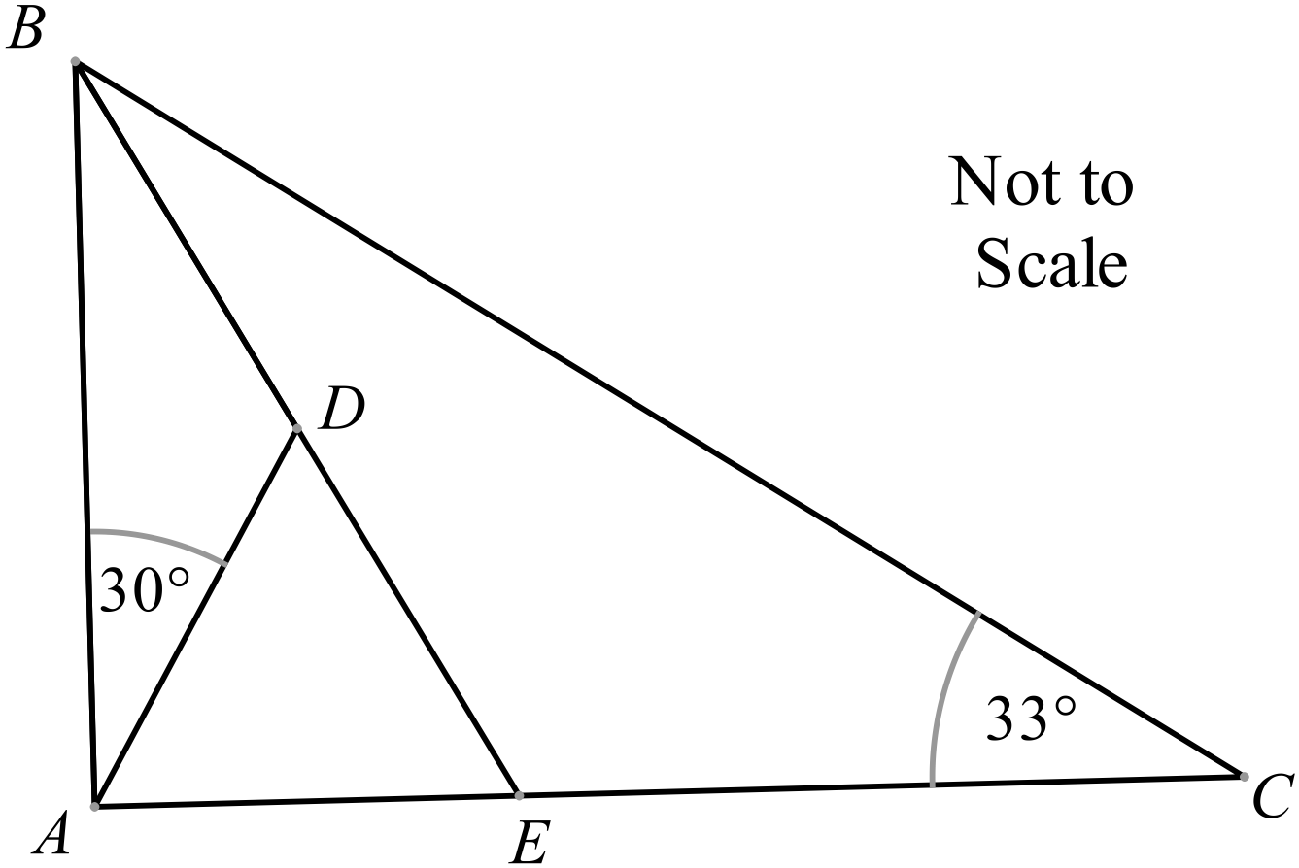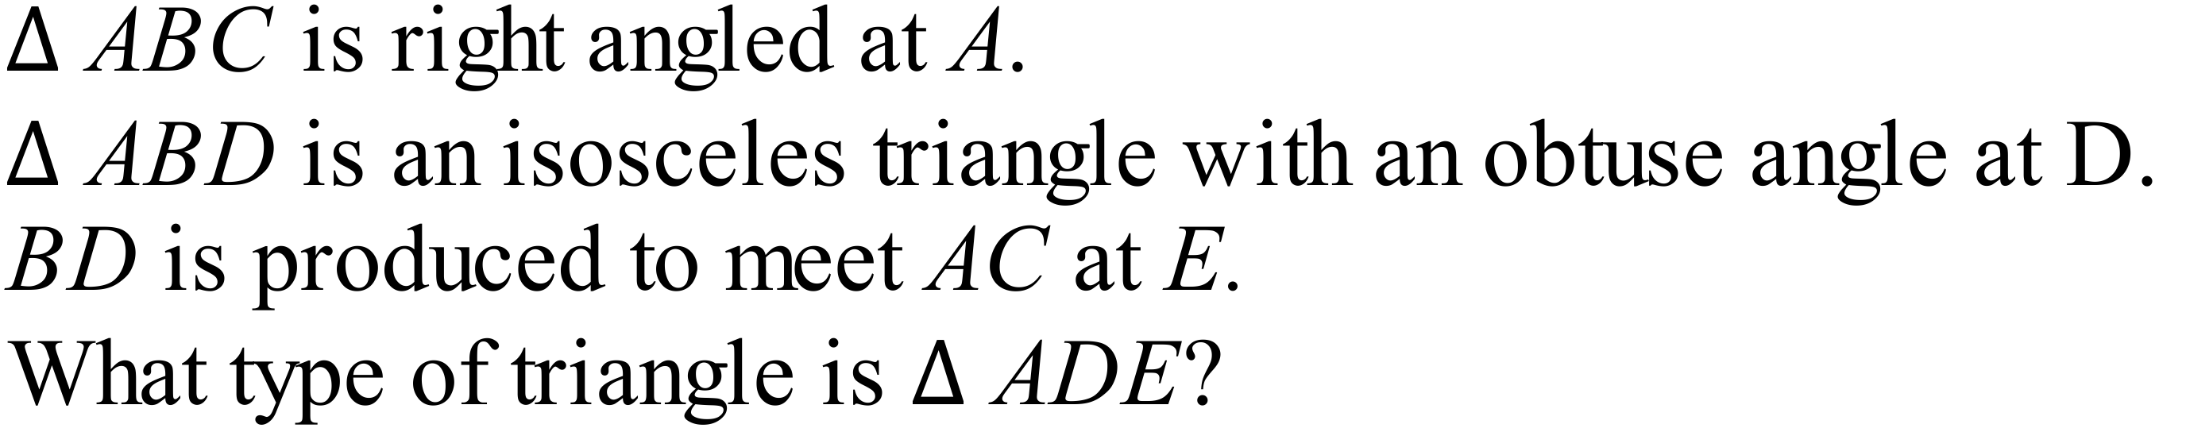  ……………………………………………………  .………………………………………………….  ……………………………………………………
10. | Olivia drives from Leeming in WA to Ballina in NSW, a distance of 4 333 km.  Write this as a distance in metres, using scientific notation.  …………………………………………………………………………………………………………….  …………………………………………………………………………………………………………….
11. | By measurement and calculation, find the perimeter of the polygon below, correct to the nearest millimetre.  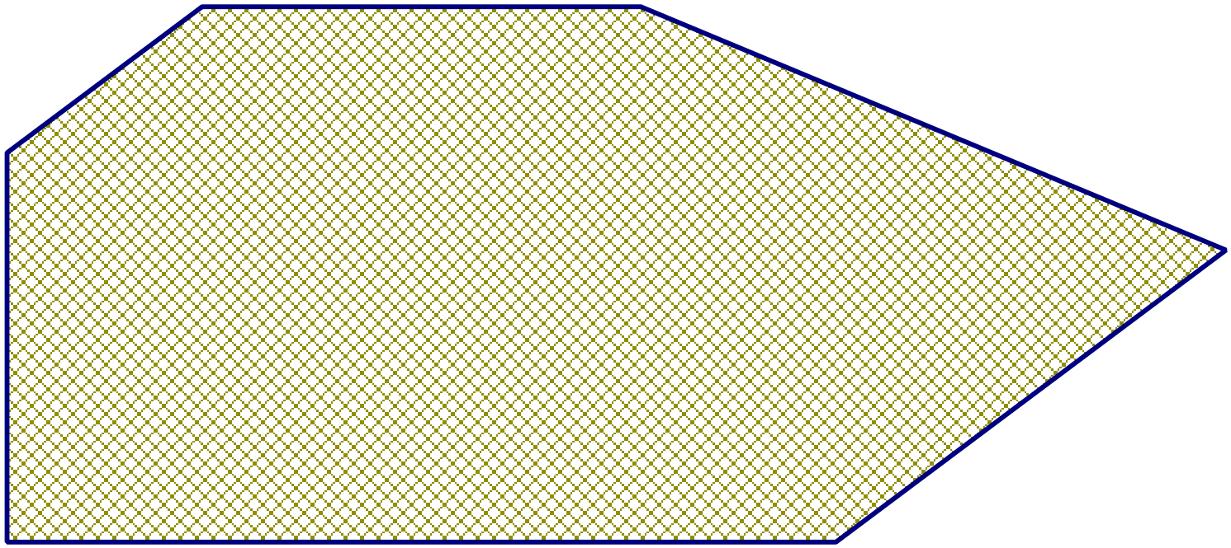  …………………………………………………………………………………………………………….  …………………………………………………………………………………………………………….
12. | Calculate the area of the shaded triangle shown below.  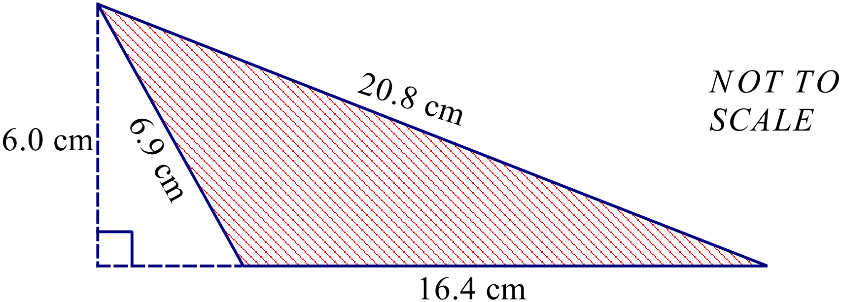  …………………………………………………………………………………………………………….  …………………………………………………………………………………………………………….
13. | 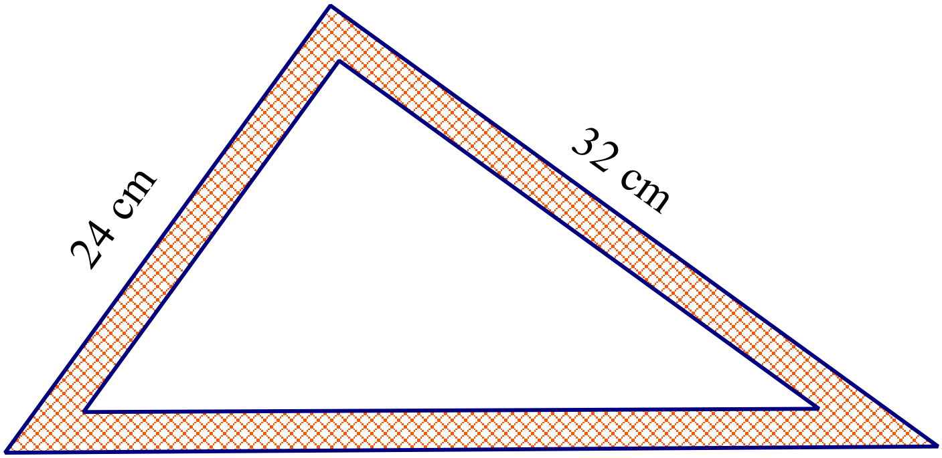A triangular set square has the measurements shown.  What is the length of it longest side?  …………………………………………………………………………………………………………….  …………………………………………………………………………………………………………….  …………………………………………………………………………………………………………….
14. | 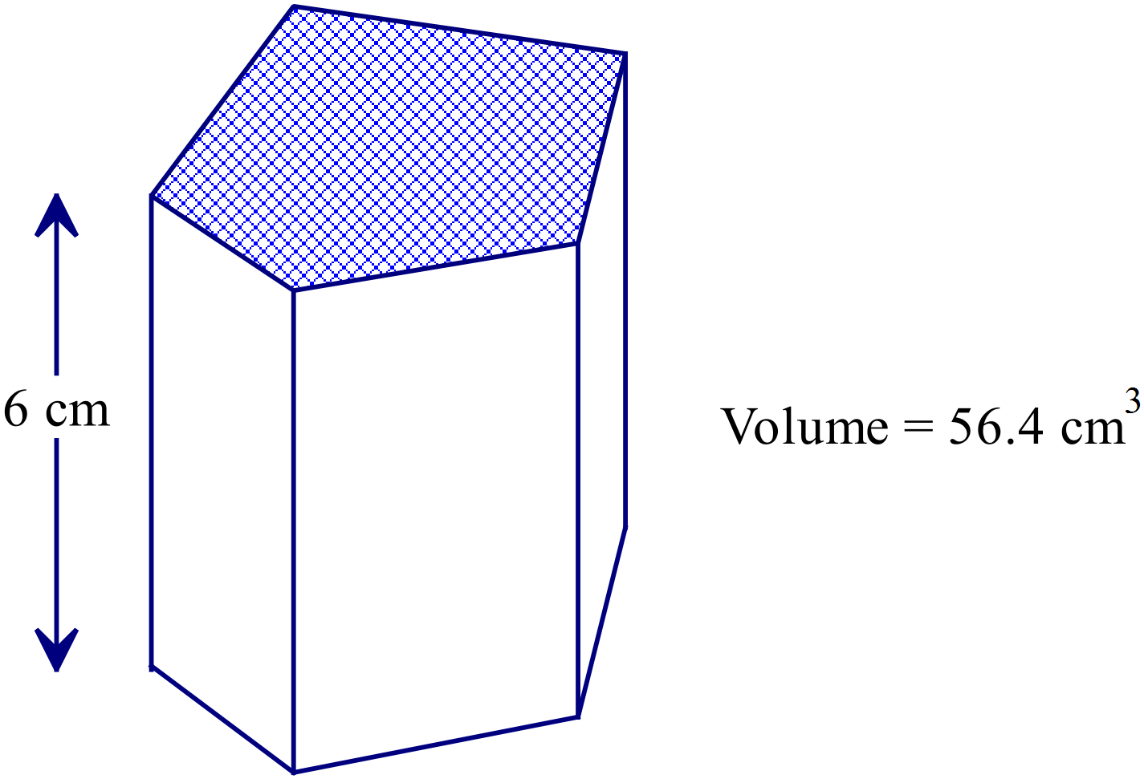What is the shaded area of the base of this prism?  ………………………………………………  ……………………………………………….  ..………………………………………………  ……………………………………………….
15. | Simplify 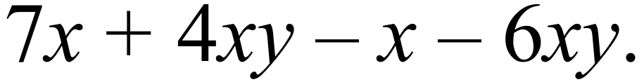  …………………………………………………………………………………………………………….  …………………………………………………………………………………………………………….
16. | Expand and simplify 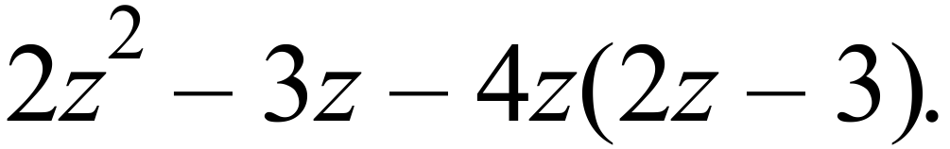  …………………………………………………………………………………………………………….  …………………………………………………………………………………………………………….
17. | Express as a single fraction in simplest form: 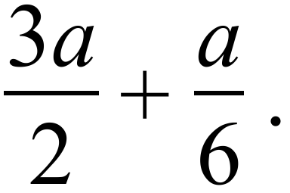  …………………………………………………………………………………………………………….  …………………………………………………………………………………………………………….
18. | 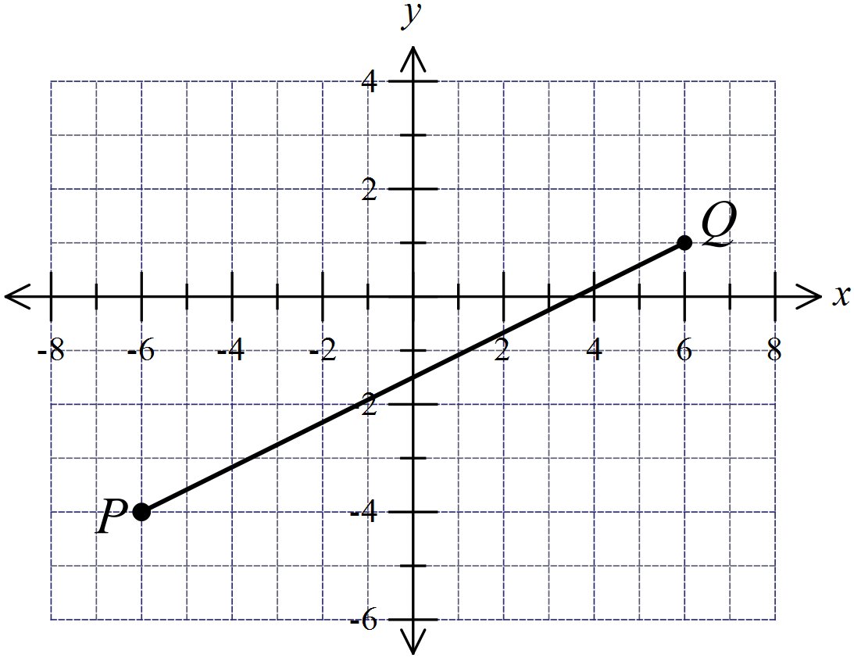P and Q are the points (-6, -4) and (6, 1) respectively.  Find the length of the interval PQ.  .…………………………………………………  ………………………………………………….  .…………………………………………………  ………………………………………………….
19. | Find the value of w for which:  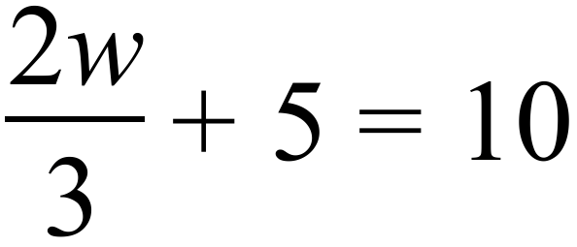  …………………………………………………………………………………………………………….  …………………………………………………………………………………………………………….  …………………………………………………………………………………………………………….
20. | Beau chooses a square at random from those shown on the grid below.  What is the probability that he chooses a number that ends in a 2 or a 4?  …………………………………………………………………………………………………………….  …………………………………………………………………………………………………………….
  42 | 15 | 27 | 34 | 62
  72 | 48 | 18 | 33 | 55
  37 | 52 | 15 | 32 | 17
  57 | 44 | 38 | 19 | 22
21. | The weather bureau reports that the probability of rain at 3 pm tomorrow is 28%.  Based on this, what is the probability that it won’t rain at 3pm tomorrow?  …………………………………………………………………………………………………………….  …………………………………………………………………………………………………………….
22. | The stem and leaf plot shows the scores from 11 shots at a dartboard.  The total score from the 11 shots was 301.  What number is represented by X?  …………………………………………………………………………………………………………….  …………………………………………………………………………………………………………….
  0 | 2
  1 | 1 | 2
  2 | 2 | X
  3 | 0 | 2 | 3
  4 | 2 | 3
  5 | 0
23. | The graph below shows the results in an election for there Year 11 representative on the SRC.  There were 150 votes counted altogether.  How many votes did the winner of the election receive?  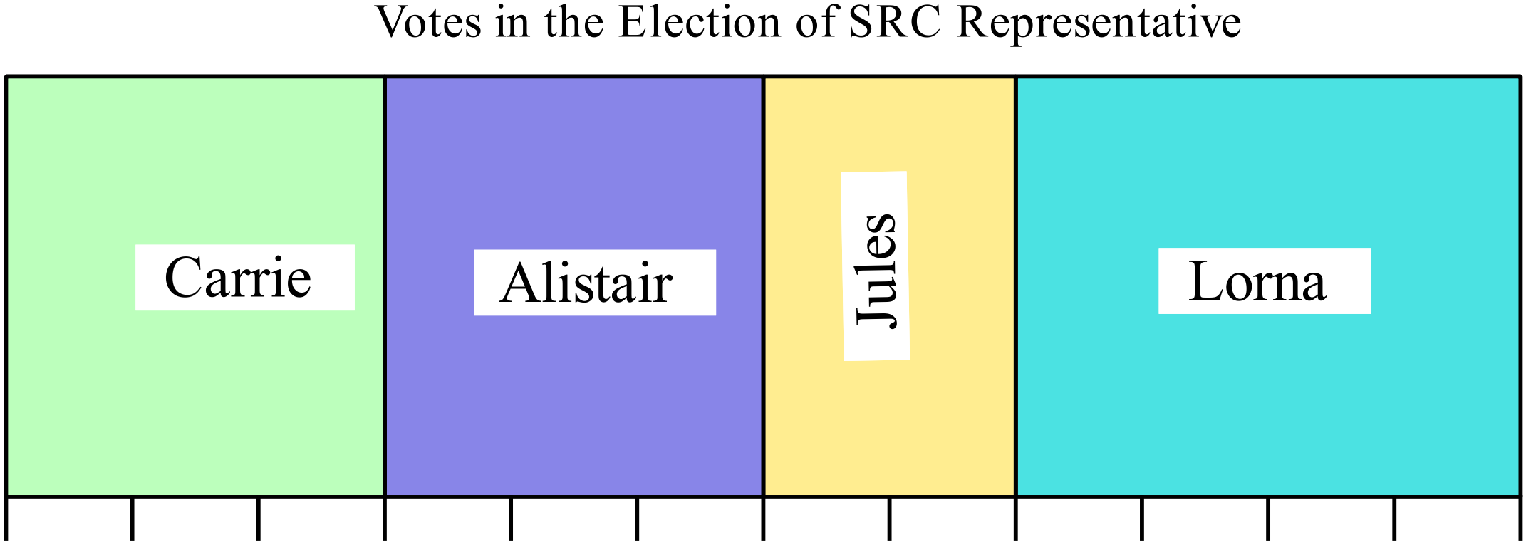  …………………………………………………………………………………………………………….  …………………………………………………………………………………………………………….
24. | Nathan’s average mark on his last four Science assessment tasks is 85%.  He has one Science task to go. What is the highest possible average he can achieve on the five tasks?  …………………………………………………………………………………………………………….  …………………………………………………………………………………………………………….
25. | Tess records her times for ten 100 metre sprints.  They were (in seconds) : 12.5, 11.2, 11.6, 11.9, 12.1, 11.4, 11.1, 11.4, 12.0, 11.0.  What is the interquartile range of the times?  …………………………………………………………………………………………………………….  …………………………………………………………………………………………………………….
 | End of Section I

Yearly Examination
Advanced Mathematics

Section 2

75 marks
Time allowed for this section is
1 hour and 30 minutes

This section has TWO parts

Part A – Fifty multiple-choice questions worth 1 mark each.
Mark your answers on the separate answer sheet provided at the end of the examination.
Part B – Longer answer questions worth a total of 25 marks.
Write all answers and working in the spaces provided on this examination paper.

Calculators may be used in this section.

Do not commence Section 2 until you are instructed to do so.

Use the multiple choice answer sheet at the end of the paper to record your answers.
Completely shade the bubble corresponding to the correct answer for each question.

Shari is on an annual salary of $83 200, which is paid weekly.
Jerome is on an hourly wage of $43.80 for a 36 hour week.
Which is true?
A. Jerome earns $23.20 per week more than Shari.
B. Jerome earns $46.40 per week more than Shari.
C. Shari earns $23.20 per week more than Jerome.
D. Shari earns $46.40 per week more than Jerome.
Massimo buys a tablet computer by paying a deposit of $80 and monthly payments of $25 for 2 years.
The cash price of the tablet was $560.
How much did he pay in interest?

A. $40 B. $120 C. $160 D. $180
Nerissa invests $5 000 in an account that pays interest at 6.4% p.a. compounded annually.
She leaves the money in the account for three years.
How much interest does she earn?
A. $960.00 B. $1 022.75 C. $1 040.16 D. $6 022.75
Elliott buys a car for $40 000 and intends to keep it until its value has roughly halved.
The graph shows the value of the car as it depreciates.
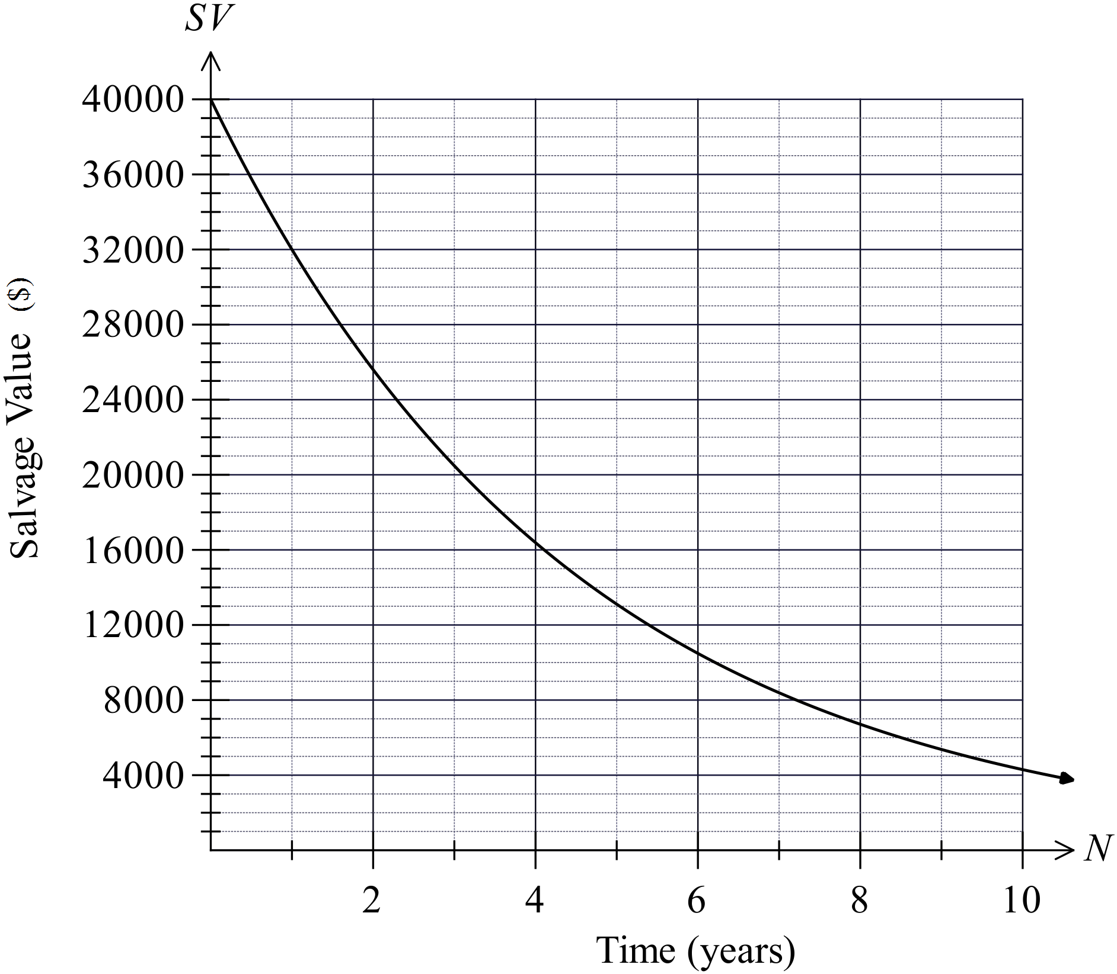How many years will Elliott keep the car?

A. 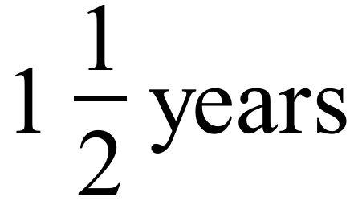
B. 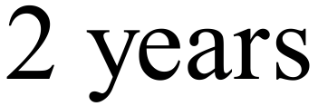
C. 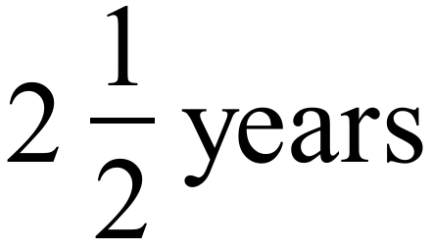
D. 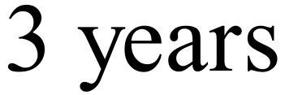

Kenzie has an annual taxable income of $45 200.
Taxable income | Tax on this income
0 – $18,200 | Nil
$18,201 – $37,000 | 19c for each $1 over $18,200
$37,001 – $80,000 | $3,572 plus 32.5c for each $1 over $37,000
$80,001 – $180,000 | $17,547 plus 37c for each $1 over $80,000
$180,001 and over | $54,547 plus 45c for each $1 over $180,000
How much income tax should she pay for the year, based on the table above?
A. $2 665 B. $3 572 C. $4 125 D. $6 237
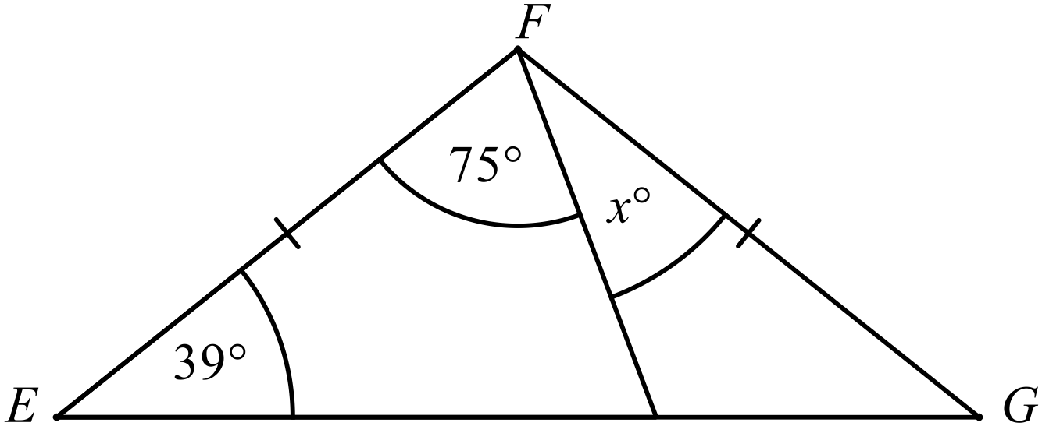
Find the value of x.

A. 27º B. 39º C. 78º D. 102º
In the diagram below, ABCD is a parallelogram and CEFD is a rhombus.
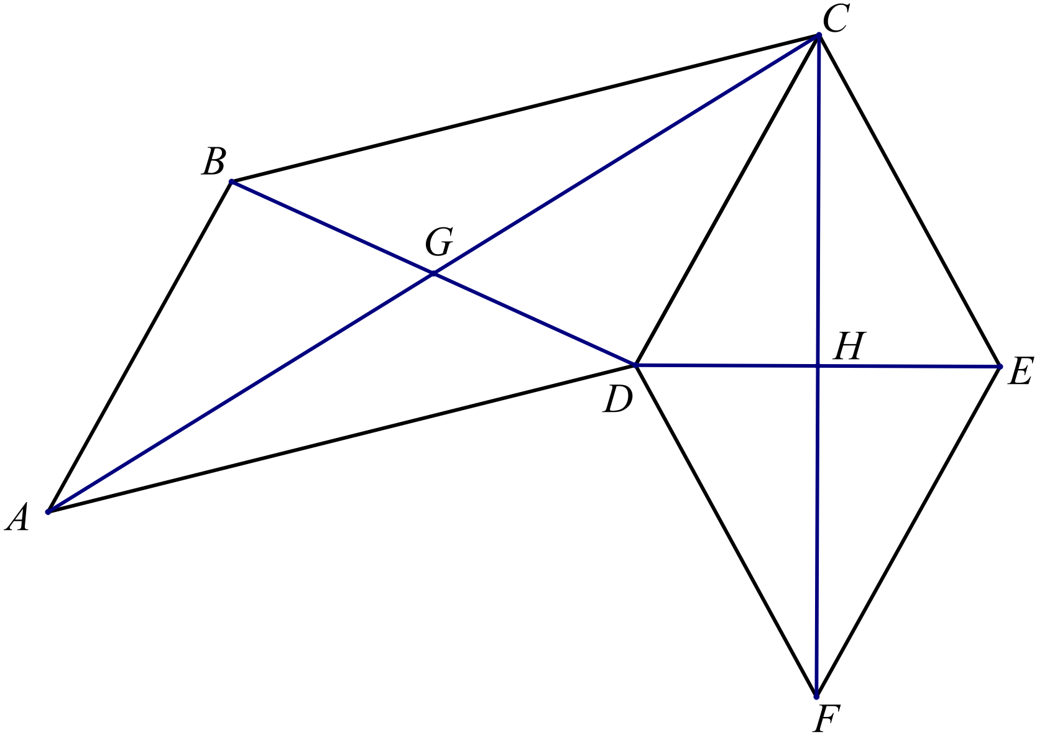Which of the following pairs of lines are perpendicular?

A. AC and BD
B. BD and CD
C. CD and DE
D. DE and CF

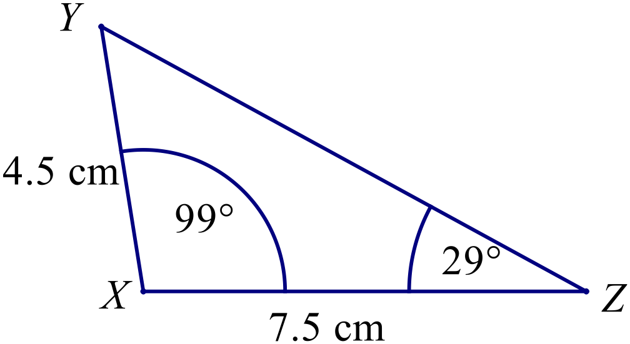Which triangle below is congruent to 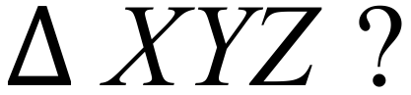

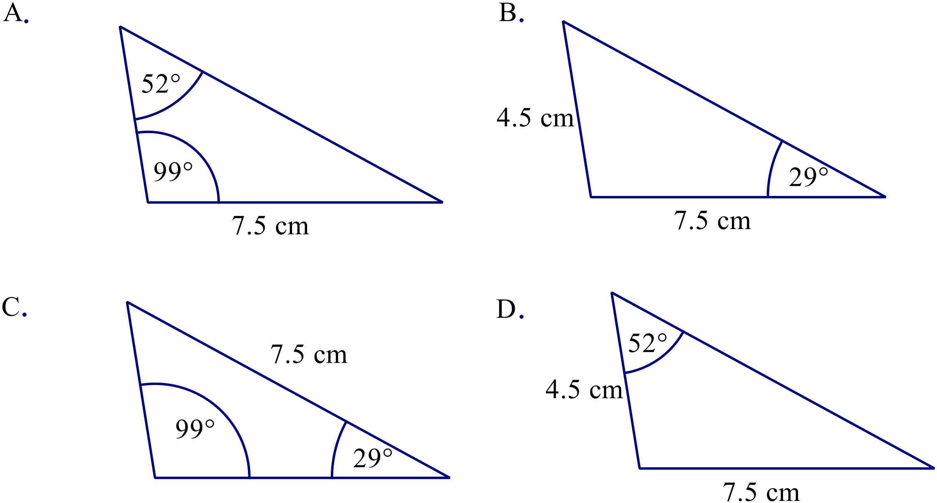

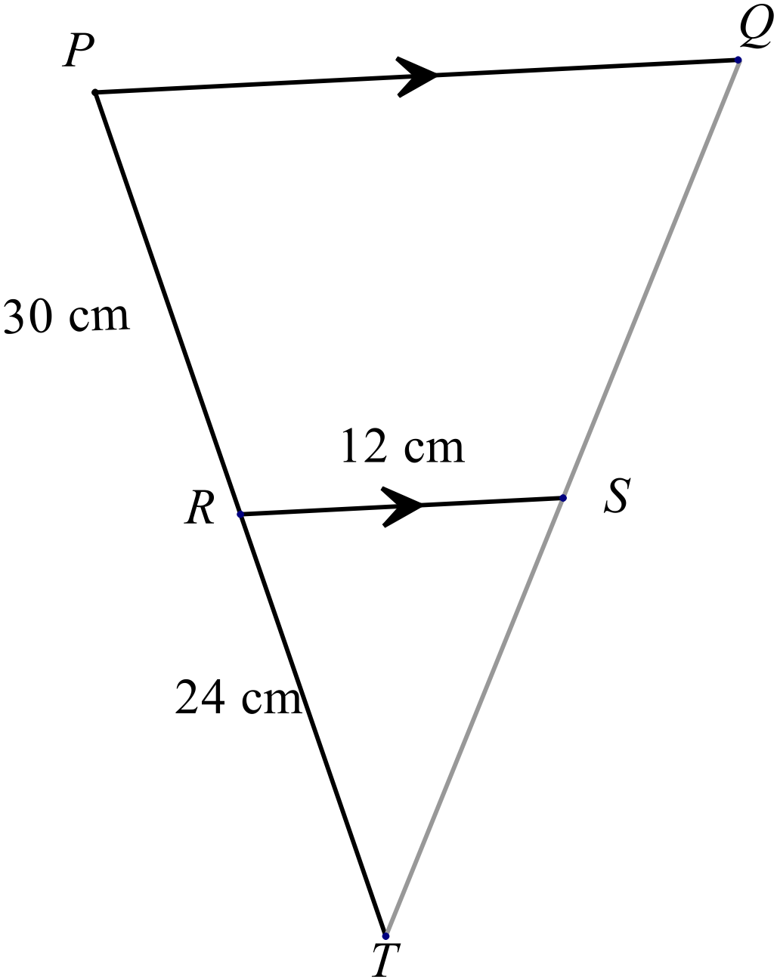In the diagram PQ || RS, PR = 30 cm, RT = 24 cm and RS = 12 cm.

What is the length of PQ?

A. 15 cm
B. 21 cm
C. 27 cm
D. 36 cm
What is the area of this shape (correct to 1 decimal place)?
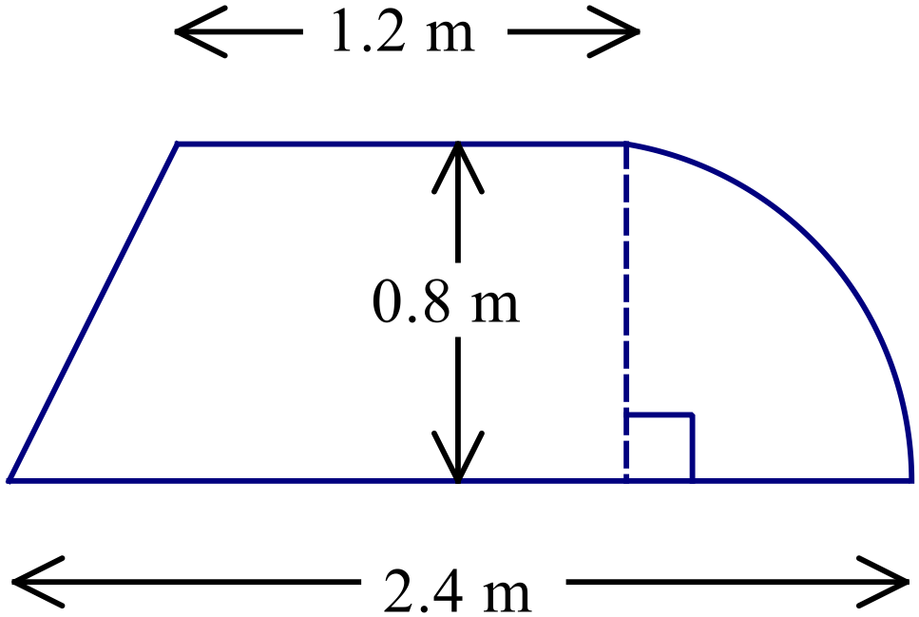

A. 0.5 m² B. 1.1 m² C. 1.6 m² D. 2.1 m²
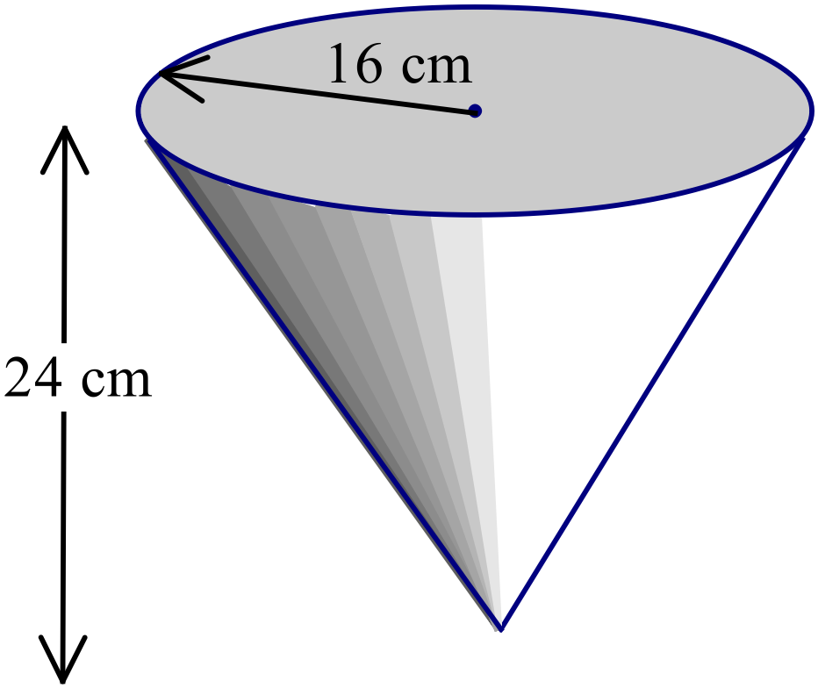What is the volume of the cone shown?

A. 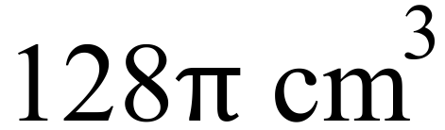
B. 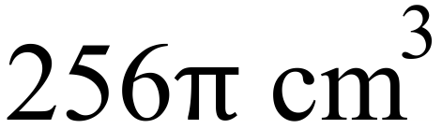
C. 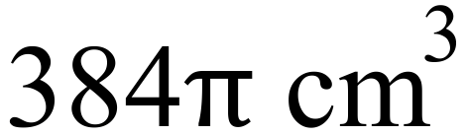
D. 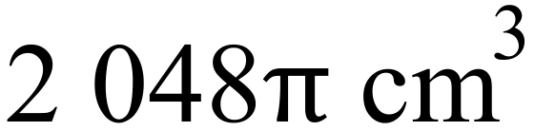
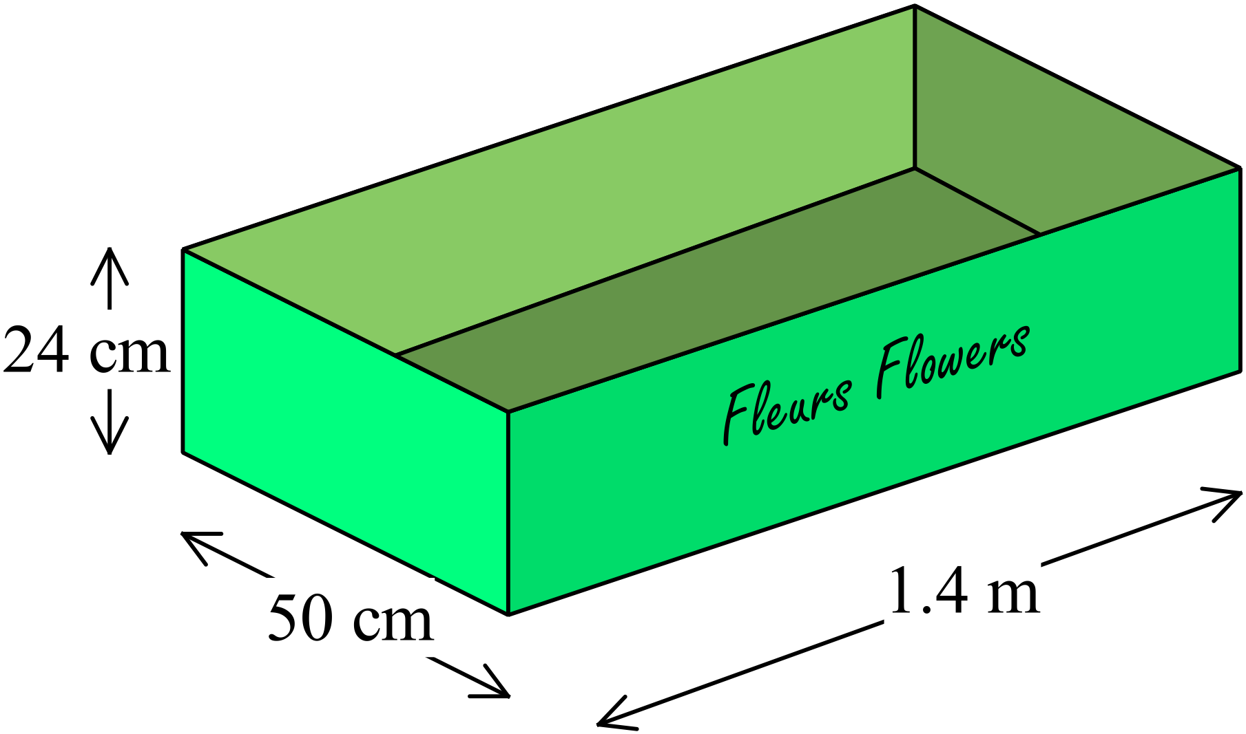Open rectangular cardboard boxes with the dimensions shown are used to pack flowers for sending to a florist.
What area of cardboard is needed for one of these boxes?

A. 2 537.2 cm² B. 2 607.2 cm²
C. 16 120 cm² D. 16 310 cm²
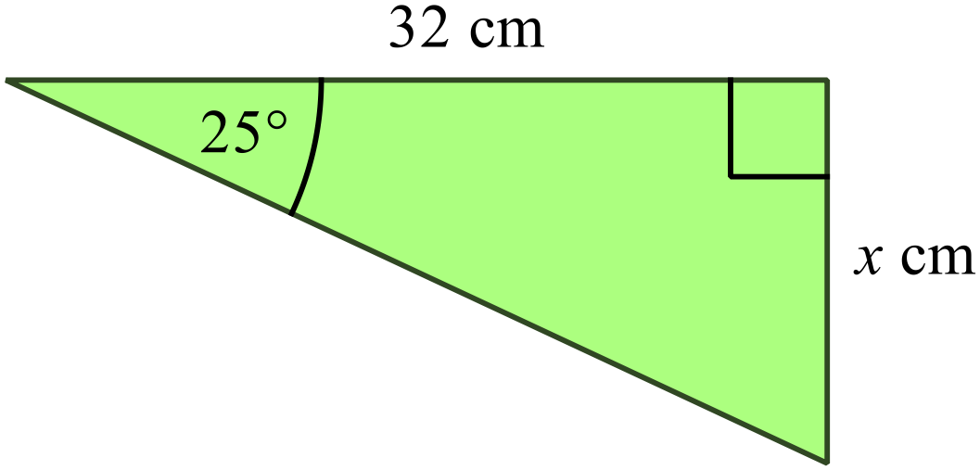What is the value of x in the diagram?

A. 13.5 B. 14.9

C. 15.6 D. 29.0

What is the angle of elevation of the top of the tower (T) from point A?
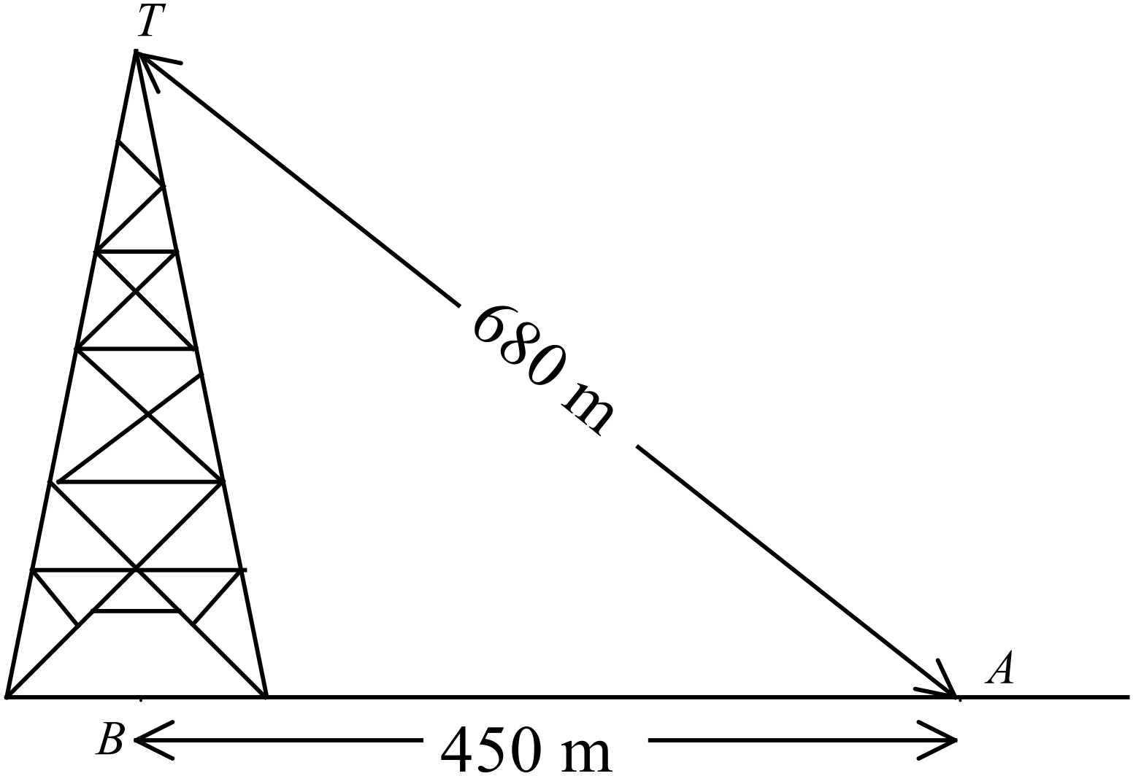

A. 33º
B. 41º
C. 49º
D. 66º
Expand and simplify 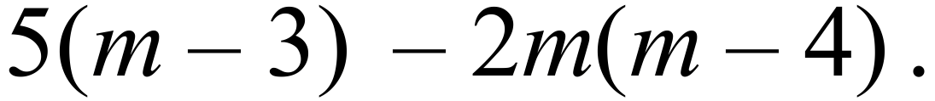
A. 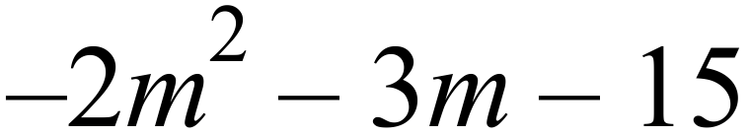
B. 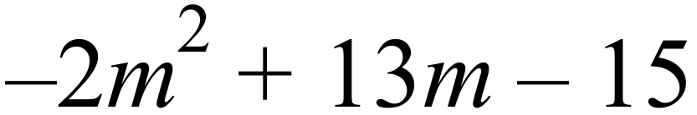
C. 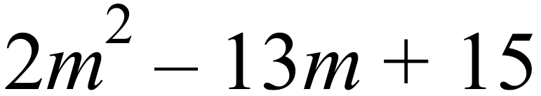
D. 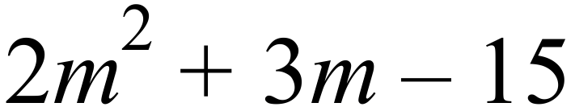
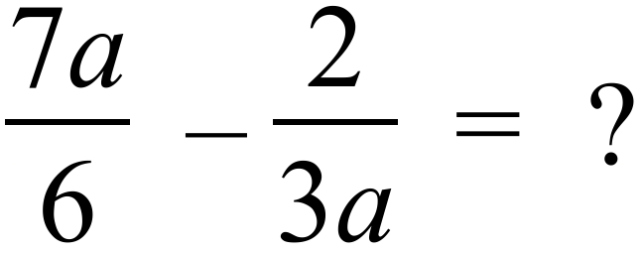
A. 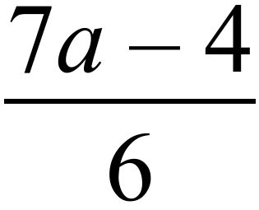 B. 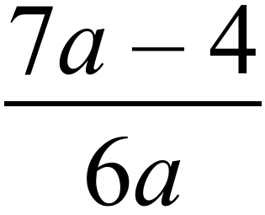 C. 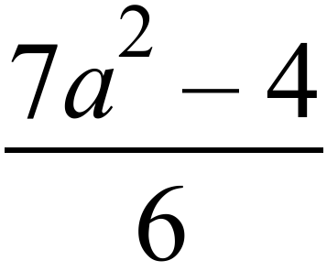 D. 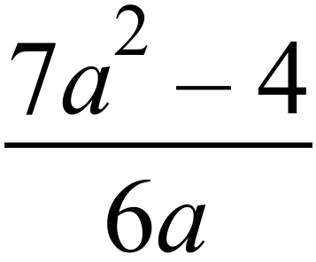
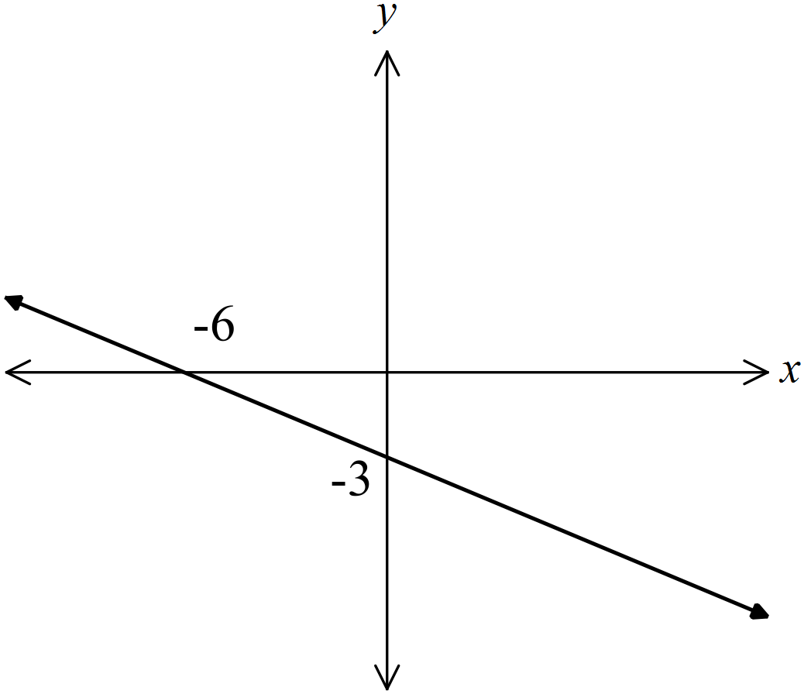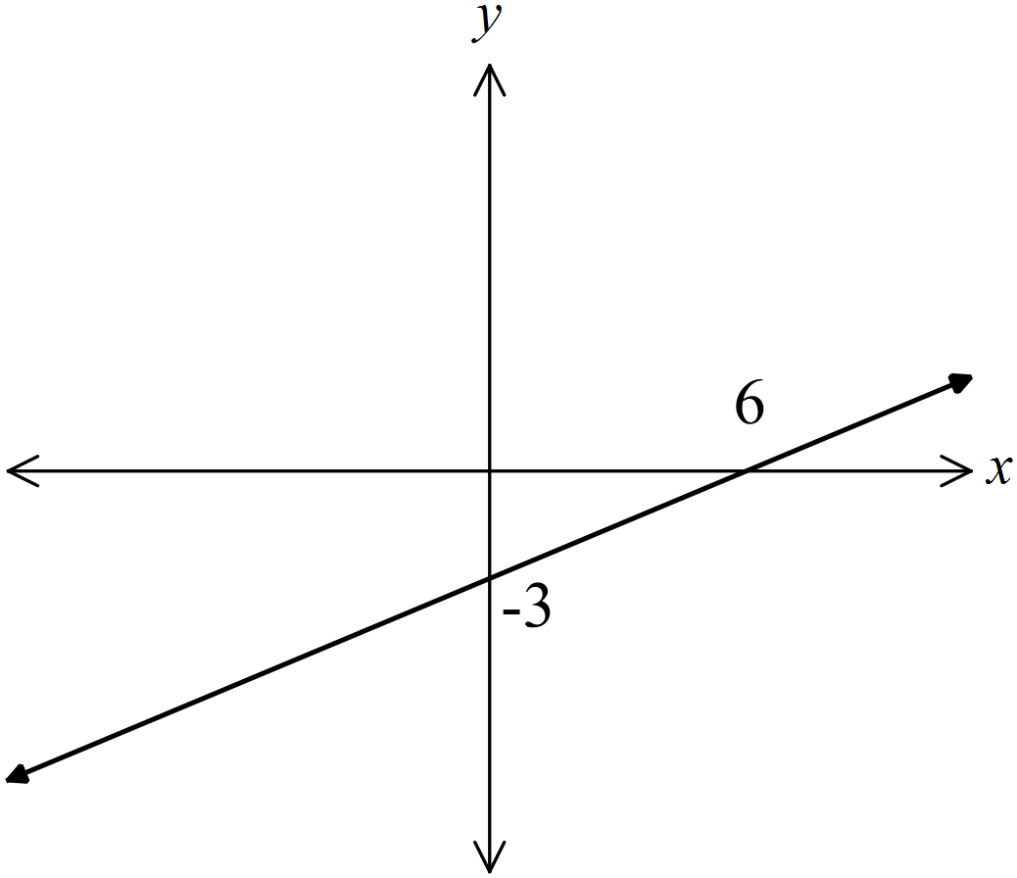Which line has an equation of 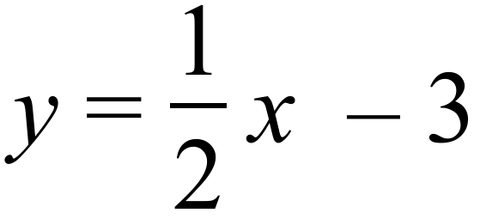 ?
A. B.

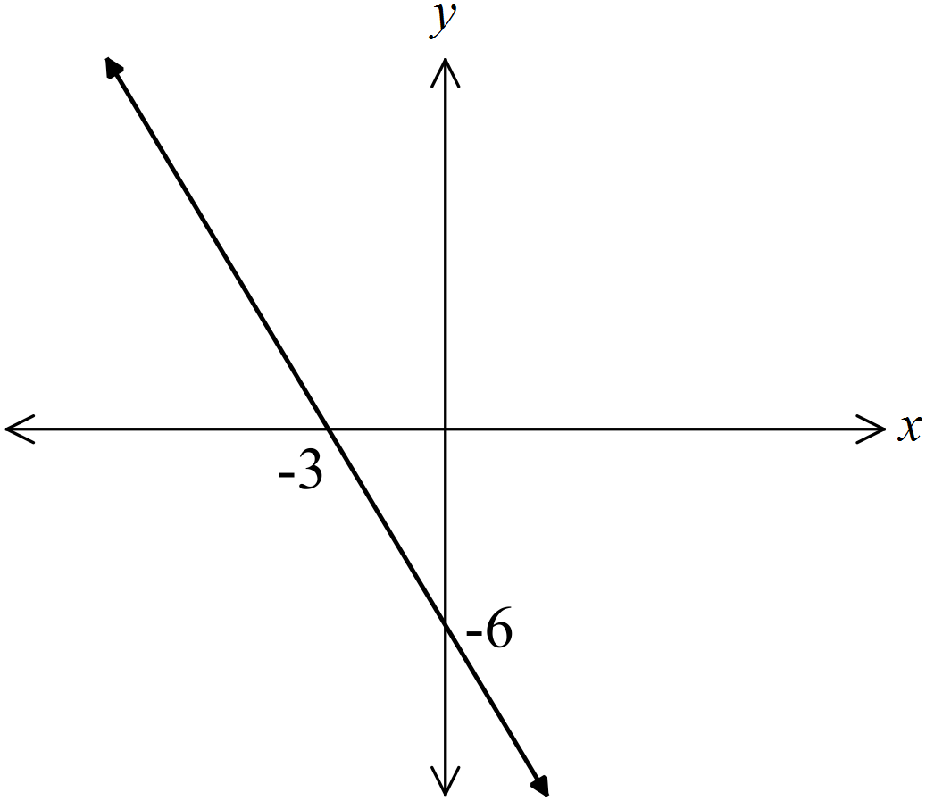
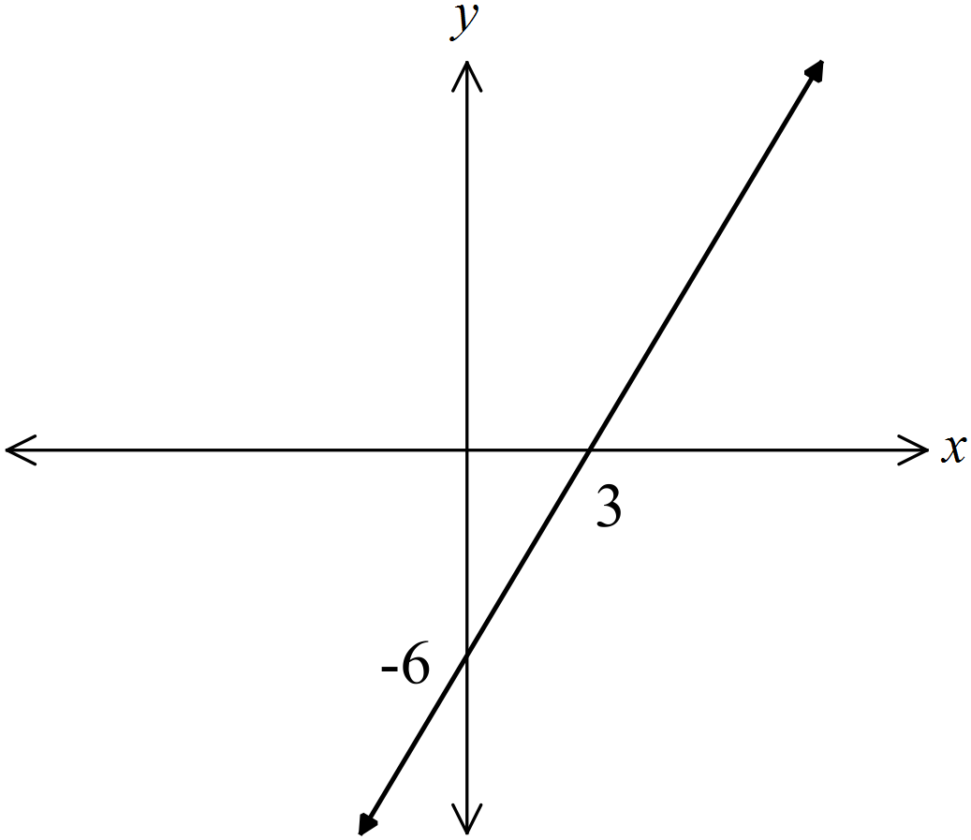 C. D.

The distance-time graph shows Noah’s trip to his grandparent’s home and back.
He started from home at noon and arrived back home at 8 pm.
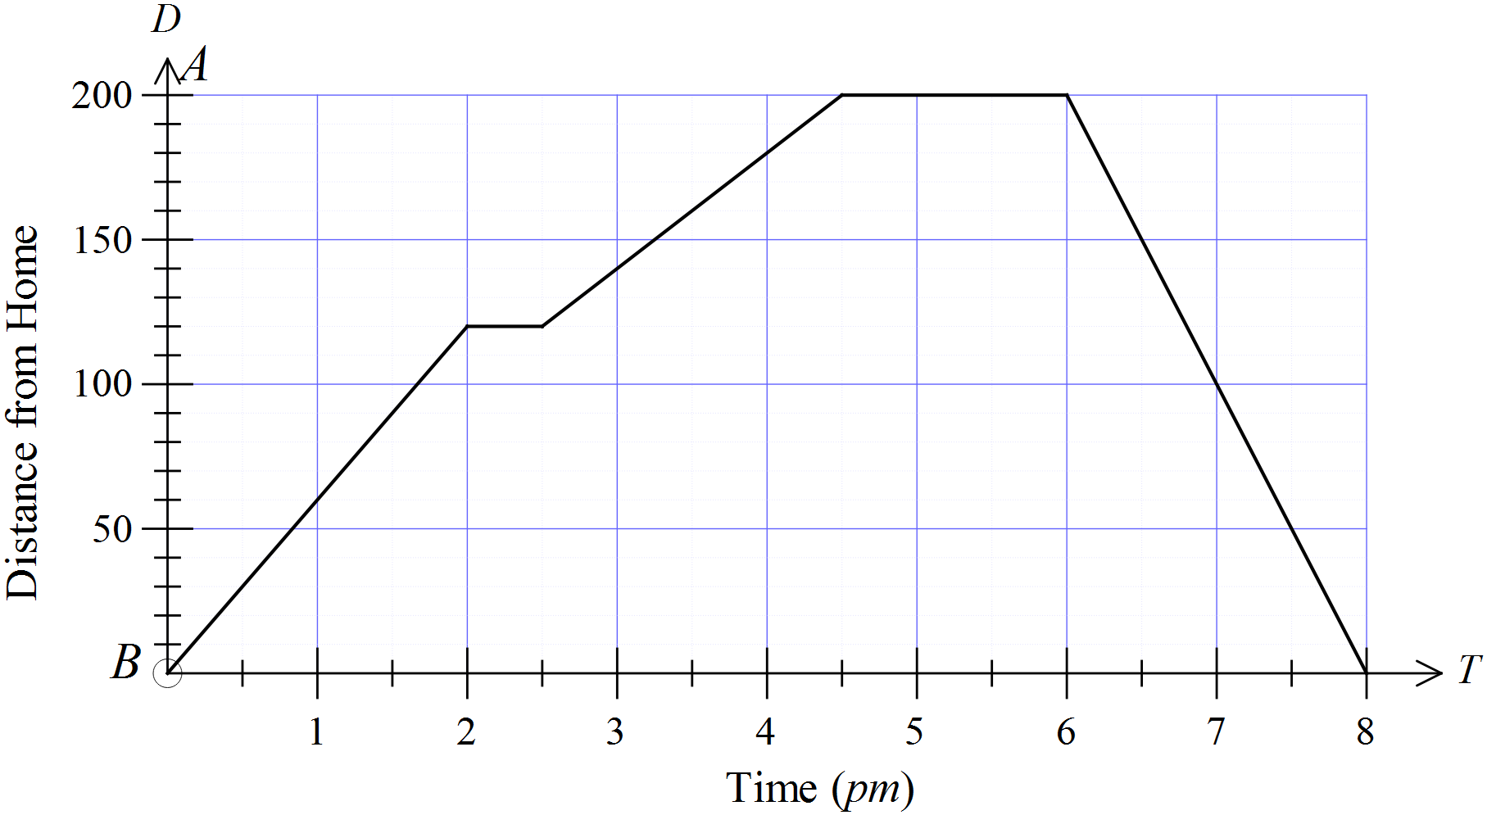

Which is not true?
A. Noah travelled at an average speed of 80 km/h on his return journey.
B. Noah stopped once on the way to his grandparent’s house.
C. Noah stayed at his grandparent’s house for an hour and a half.
D. Noah’s slowest average speed (apart from being stopped) was between 2:30 pm and 4:30 pm.
Which expression is not equivalent to 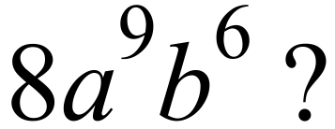

A. 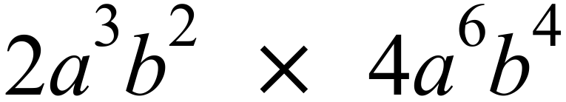 B. 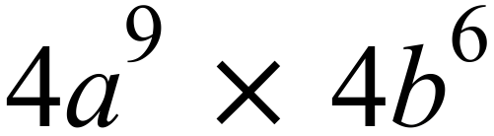
C. 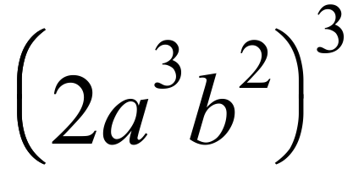 D. 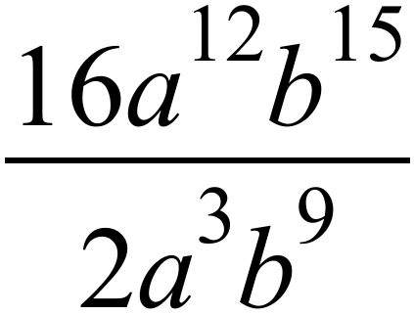
Which inequality has its solution graphed below?
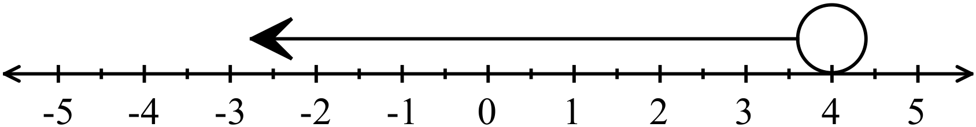

A. 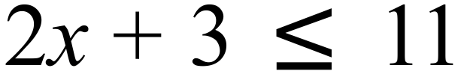 B. 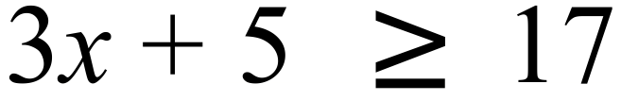
C. 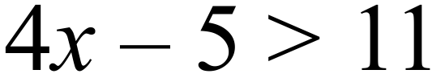 D. 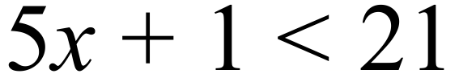
Hunter, Iain and Jason run against one another in a three man race.
Hunter has a 1 in 7 chance of winning and Iain is twice as likely to win as Jason.
What is the probability that Jason wins?
A. 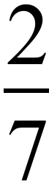 B. 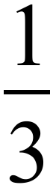 C. 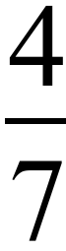 D. 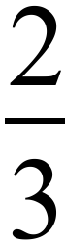
Which of these will always have a probability of 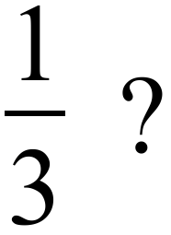
A. Rolling a 2 or a 5 on a single roll of a fair die.
B. Drawing a club from a normal pack of cards.
C. Reaching a set of traffic lights when they are showing red.
D. Drawing a red marble from a bag which holds one red and three yellow marbles.
The graph is a grouped frequency histogram which shows the ages of people at Jamie’s party.

Use the graph to estimate the mean of the data.
A. 17.0 B. 17.4 C. 18.0 D. 18.4
A real estate website gives the median house price for each suburb. The median was used because:
A. The median is calculated using all the prices and the mean is not.
B. The median gives a better idea of the spread of the data.
C. The median is less effected by outliers than the mode.
D. The median is less effected by outliers than the mean.
Which scatter graph indicates there is a positive linear relationship between the two variables?
A. B.

C. D.

Sophia is charged 16.5% p.a. simple interest (calculated on a daily basis) on the outstanding balance on her credit card.
She has an outstanding balance of $456.00 which she pays off, along with the interest owing after 21 days.
How much does she pay off?
A. $460.33 B. $462.27 C. $531.24 D. $2 036.04
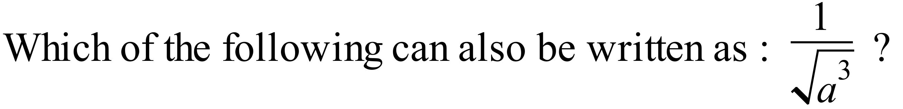
A. 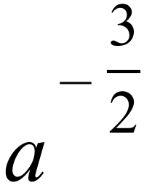 B. 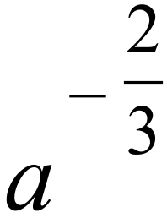 C. 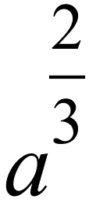 D. 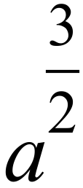
Simplify $\sqrt{2}\left(2\sqrt{3}-3\sqrt{5 } \right)-\sqrt{160}$ = ?

A. 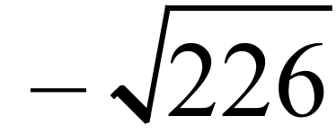 B. 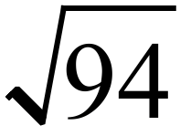 C. 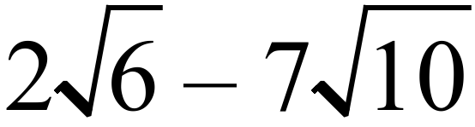 D. 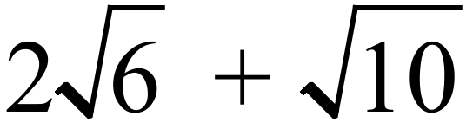
D and E are points on AB and AC respectively.
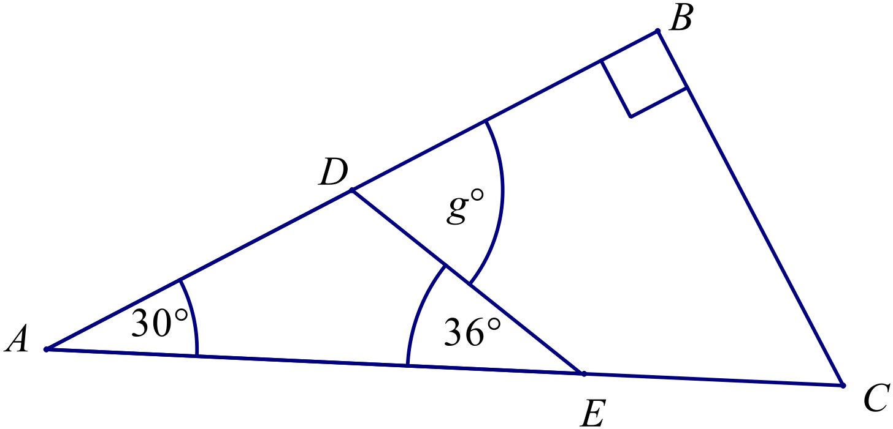
Find the value of g.

A. 60º
B. 66º
C. 72º
D. 144º
What is the size of an interior angle in a regular dodecagon (12 sided polygon)?

A. 36º B. 120º C. 144º D. 150º
Which congruence test could be used to prove that 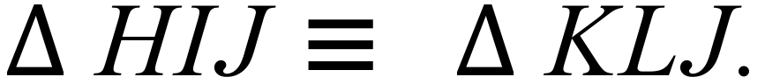
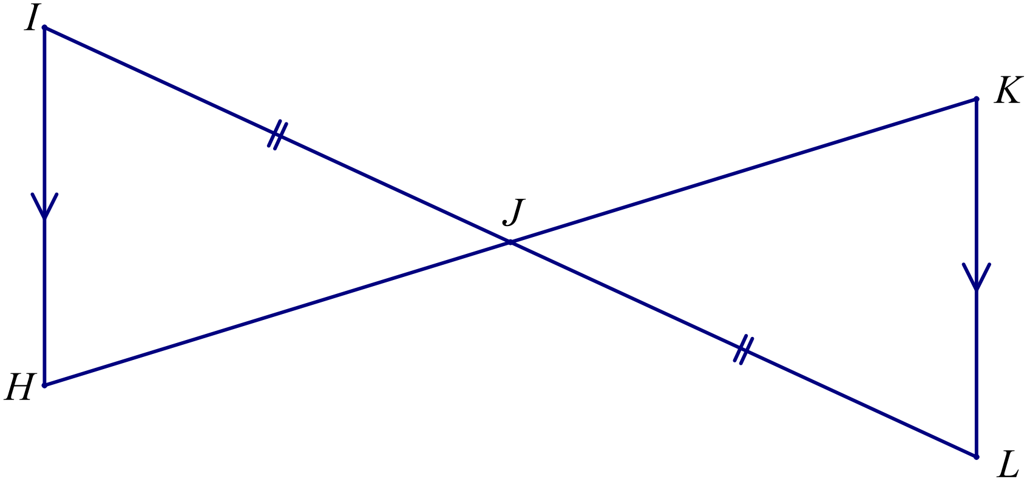
A. AAS
B. RHS
C. SAS
D. SSS

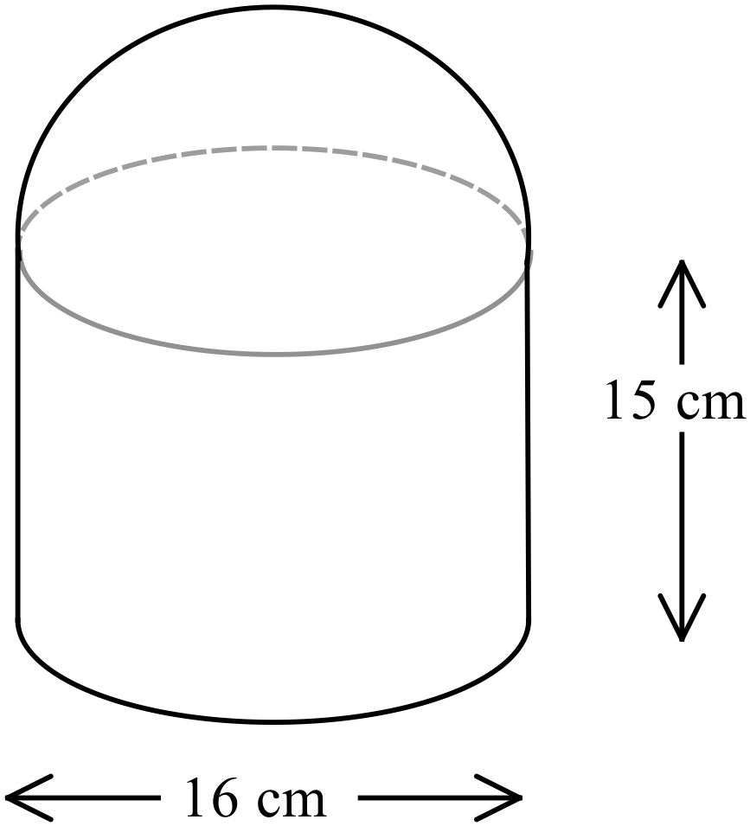The solid shown comprises a cylinder topped by a hemisphere.
Find the volume of the solid.
A. 1 072 cm³
B. 3 016 cm³
C. 4 088 cm³
D. 5 161 cm³
Find the surface area of the square pyramid shown.
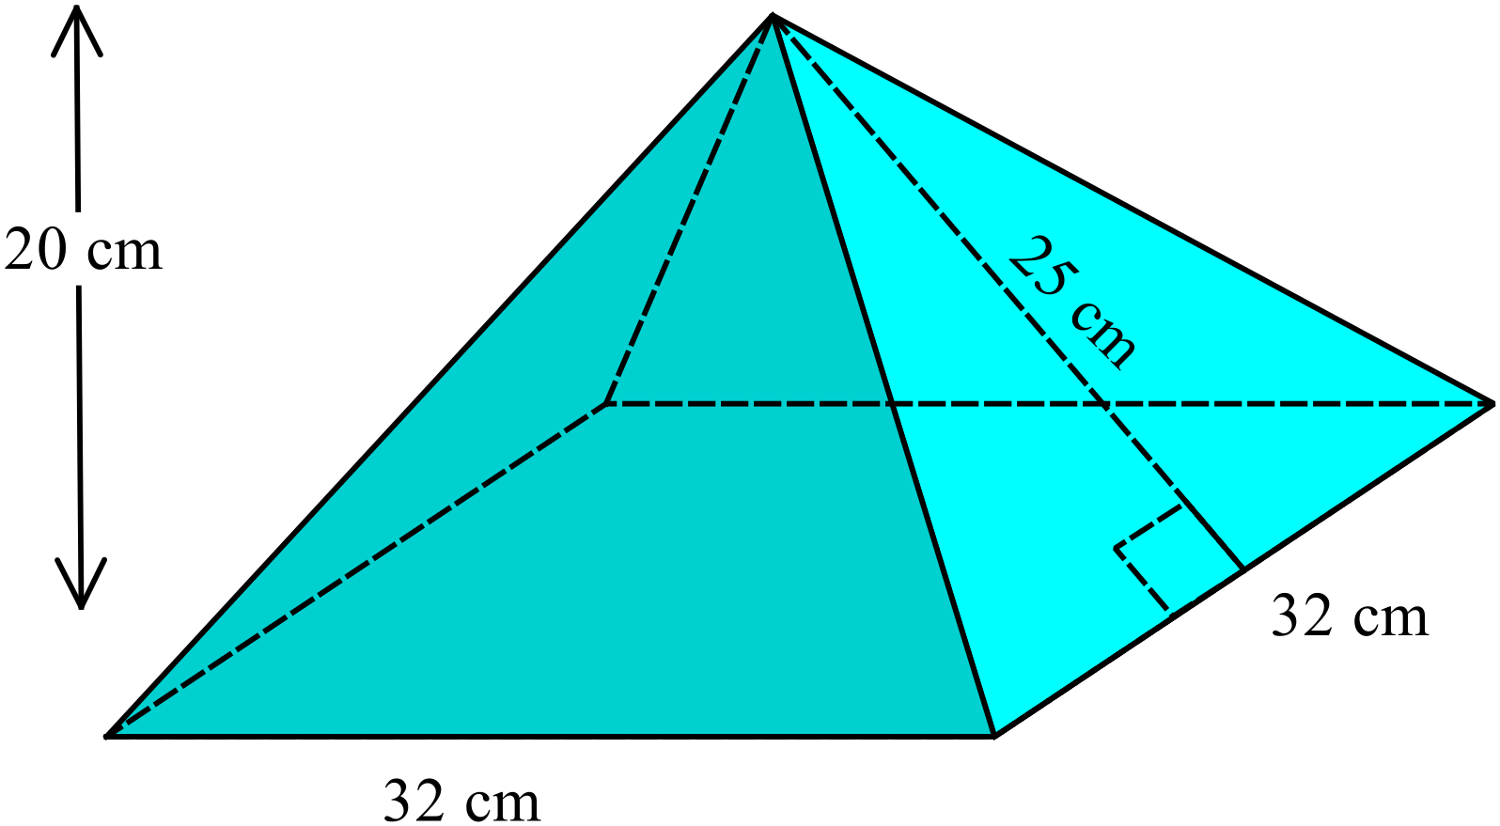

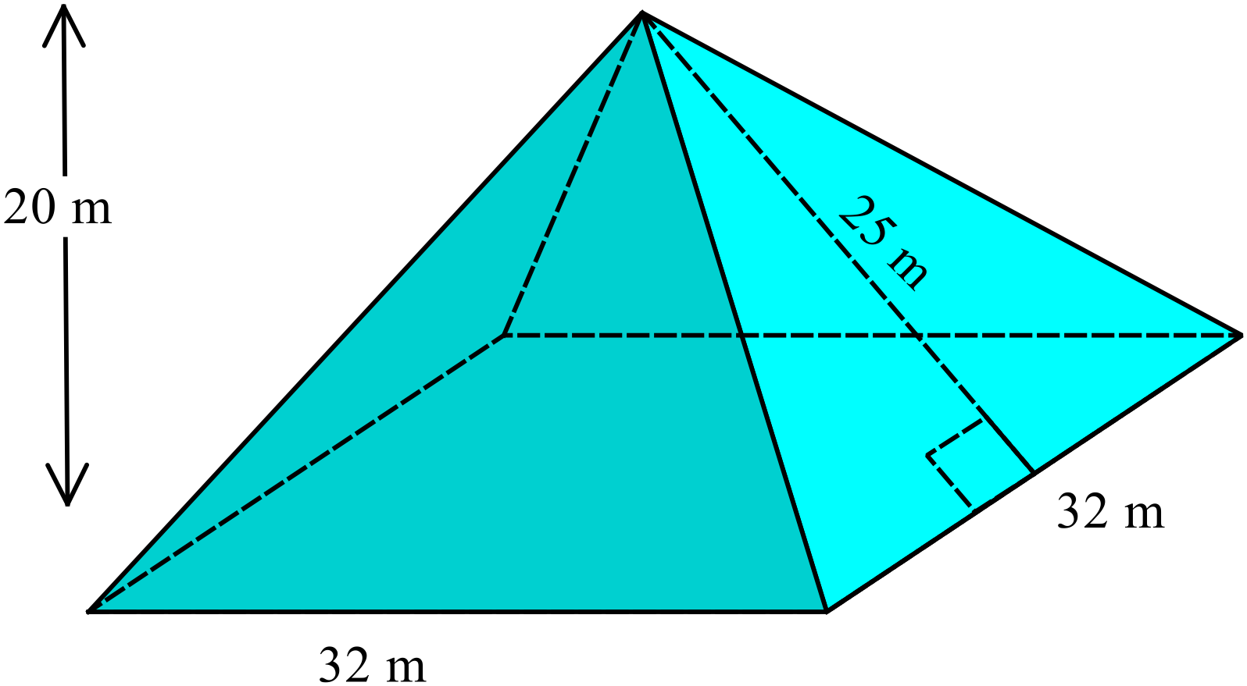

A. 2 240 cm² B. 2 624 cm² C. 3 264 cm² D. 3 328 cm²
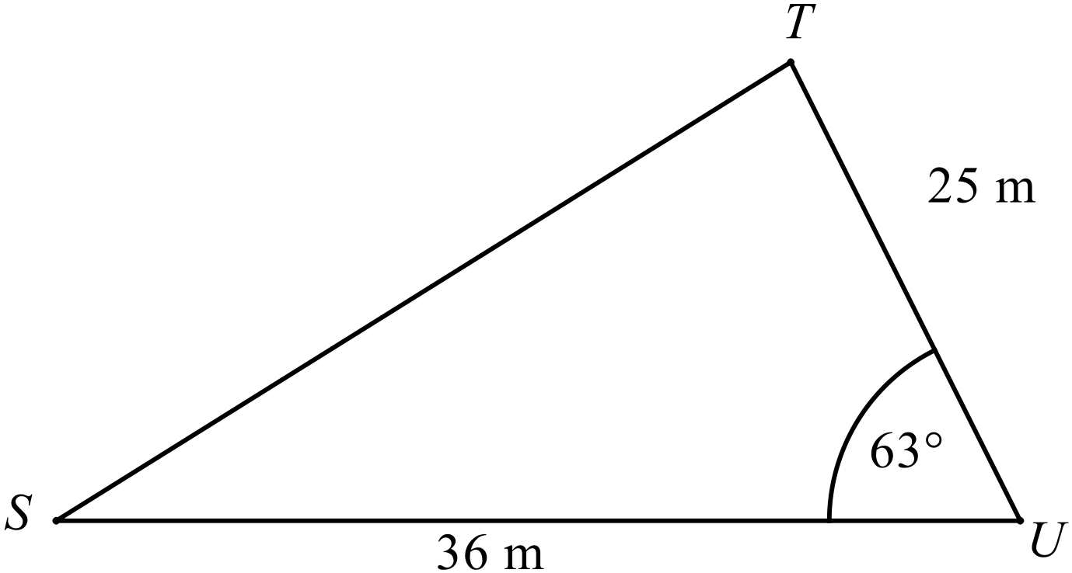Find the distance ST in the triangle shown below.

A. 11.1 m B. 17.8 m C. 33.2 m D. 41.4 m
Find the value of 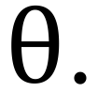
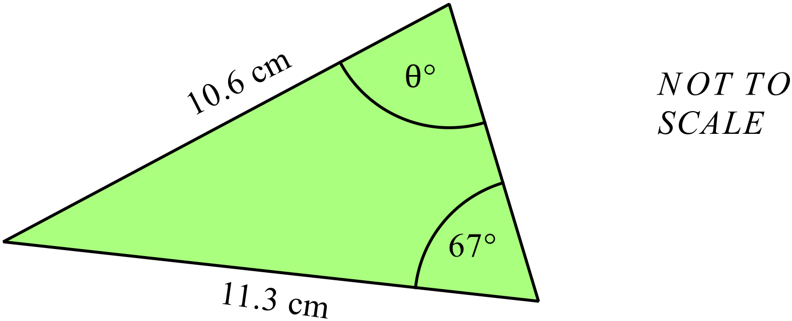

A. 11º B. 30º C. 60º D. 79º

What is the equation of the line that passes through the points A(-3, 2) and B(5, -2) on the number plane ?
A. 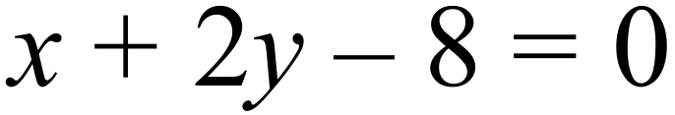
B. 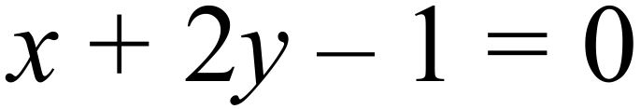
C. 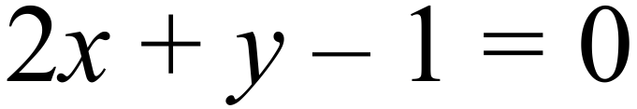
D. 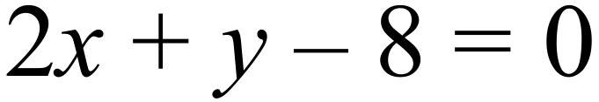
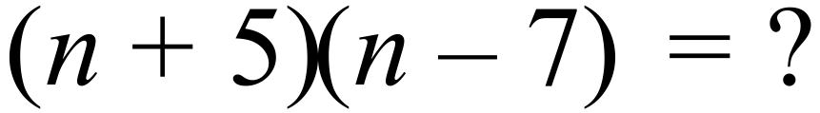
A. 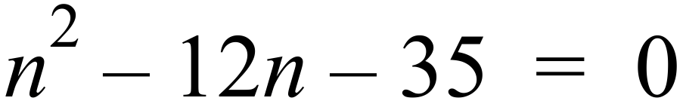
B. 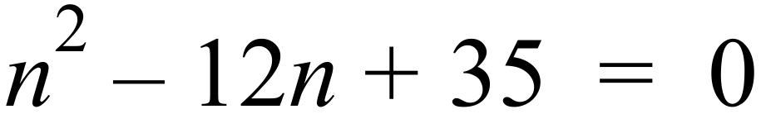
C. 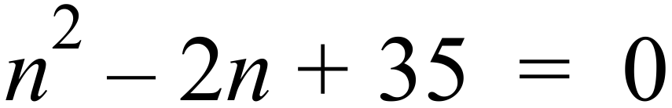
D. 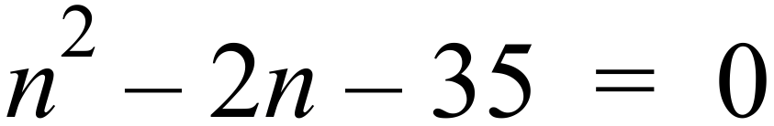
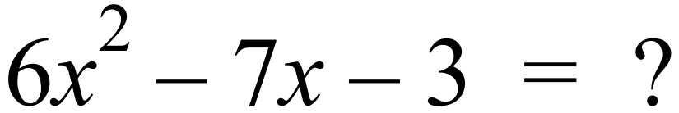
A. 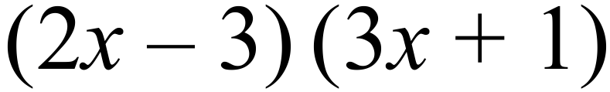
B. 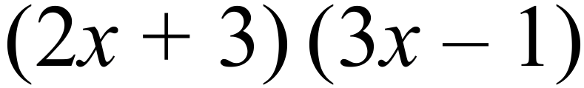
C. 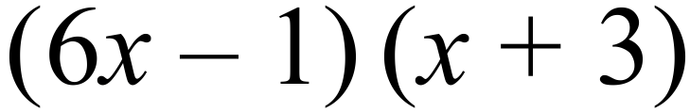
D. 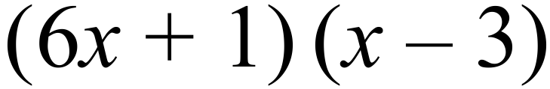
At what point does the line 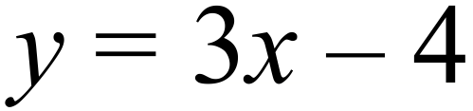 intersect the line 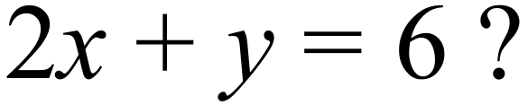
A. (-2, -2) B. (2, -2) C. (-2, 2) D. (2, 2)
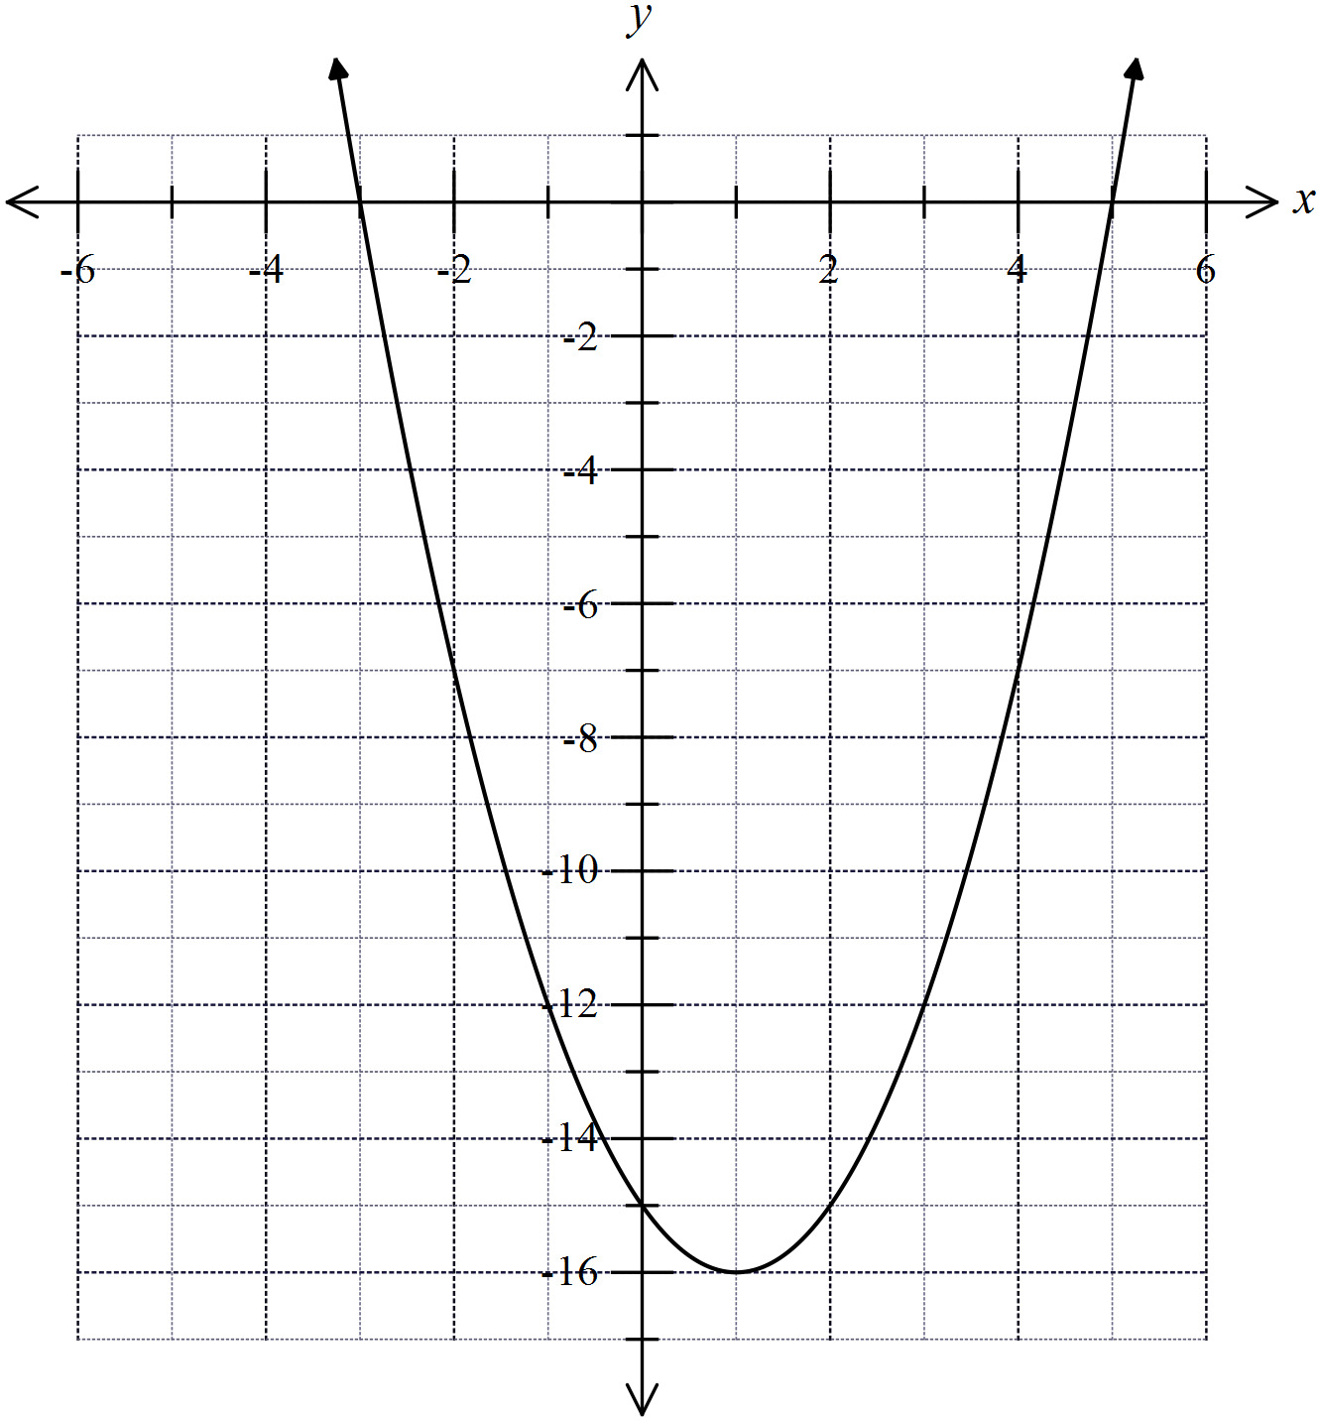At what points does the line 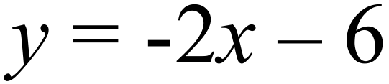 intersect the curve shown below?

A. (-1, -12) and (5, 0)
B. (-3, 0) and (0, -14)
C. (-3, 0) and (3, -12)
D. (-1, -12) and (2, -15)
Perfume is poured into a bottle at a constant rate.
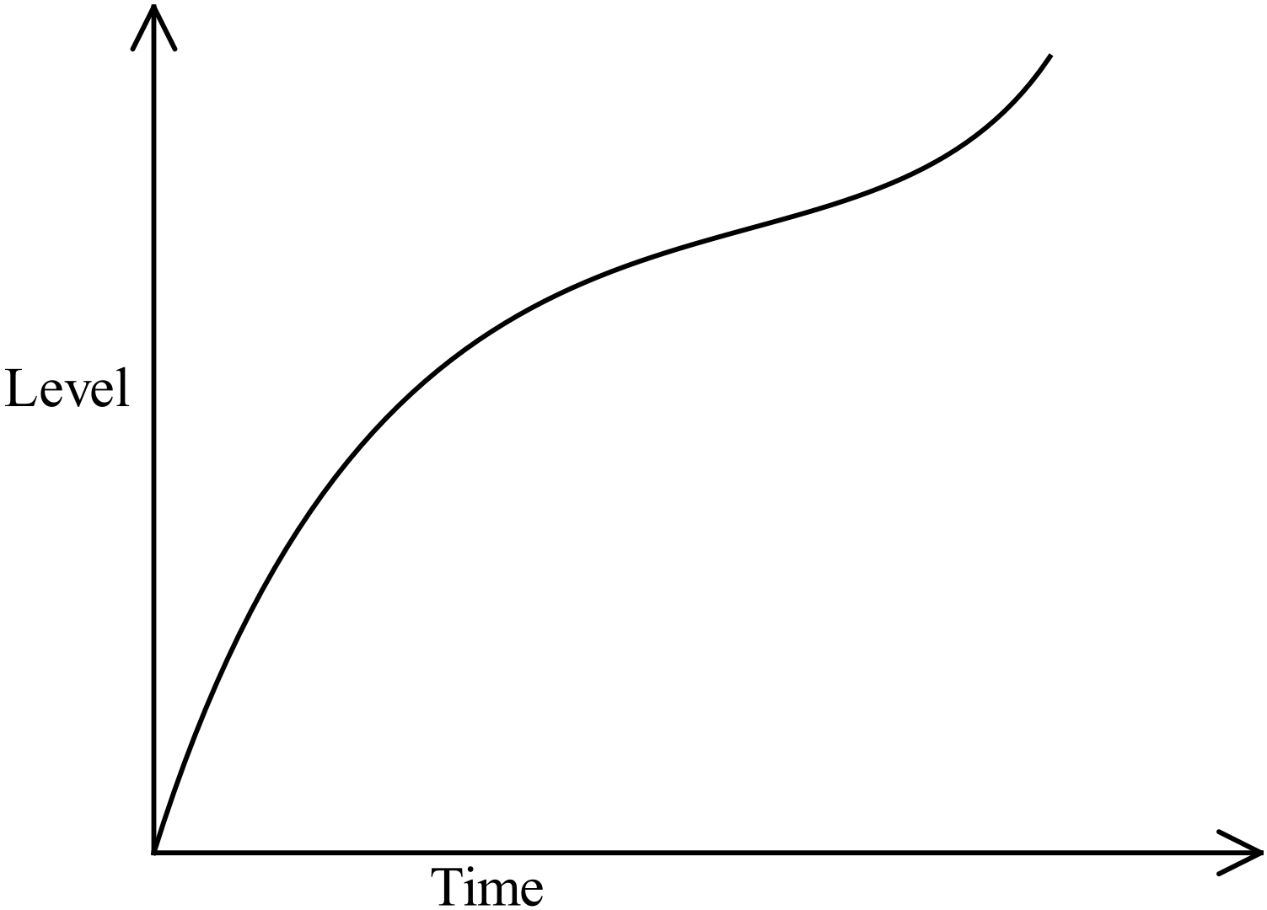The graph shows the rate at which the level of perfume rises up the side of the bottle.

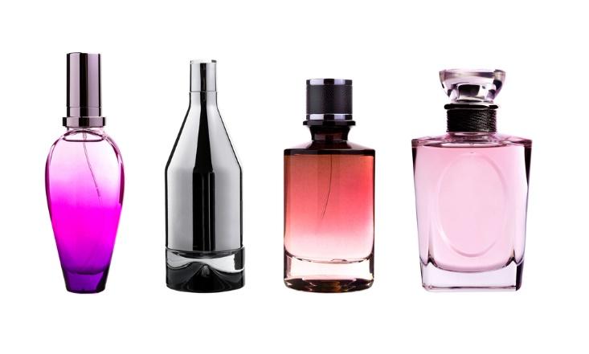
To which bottle could this graph refer?
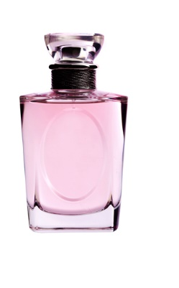
A. B. C. D.

Solve 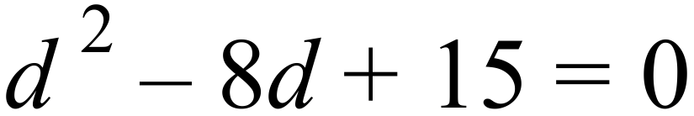
A. 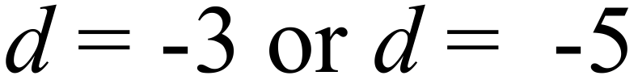
B. 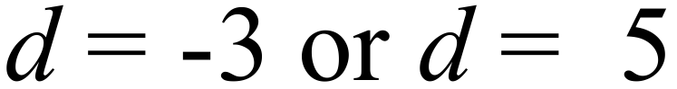
C. 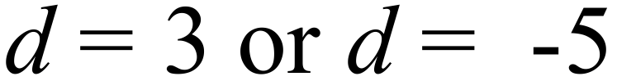
D. 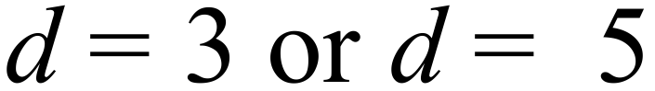
Find the exact solution to 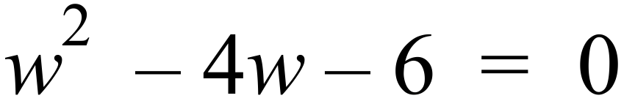 .
A. 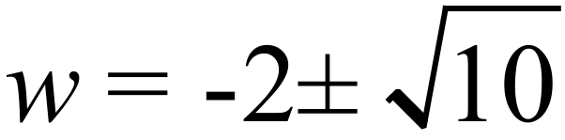 B. 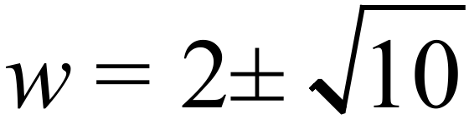
C. 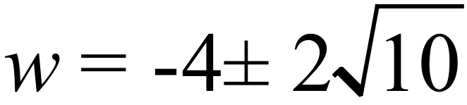 D. 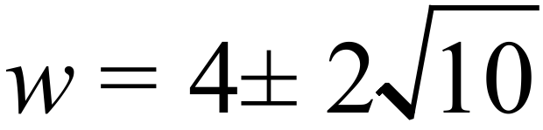
Which graph could represent the equation 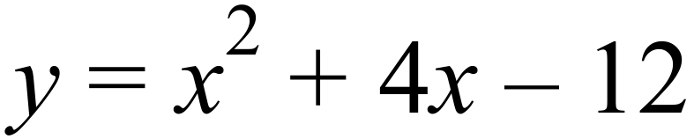
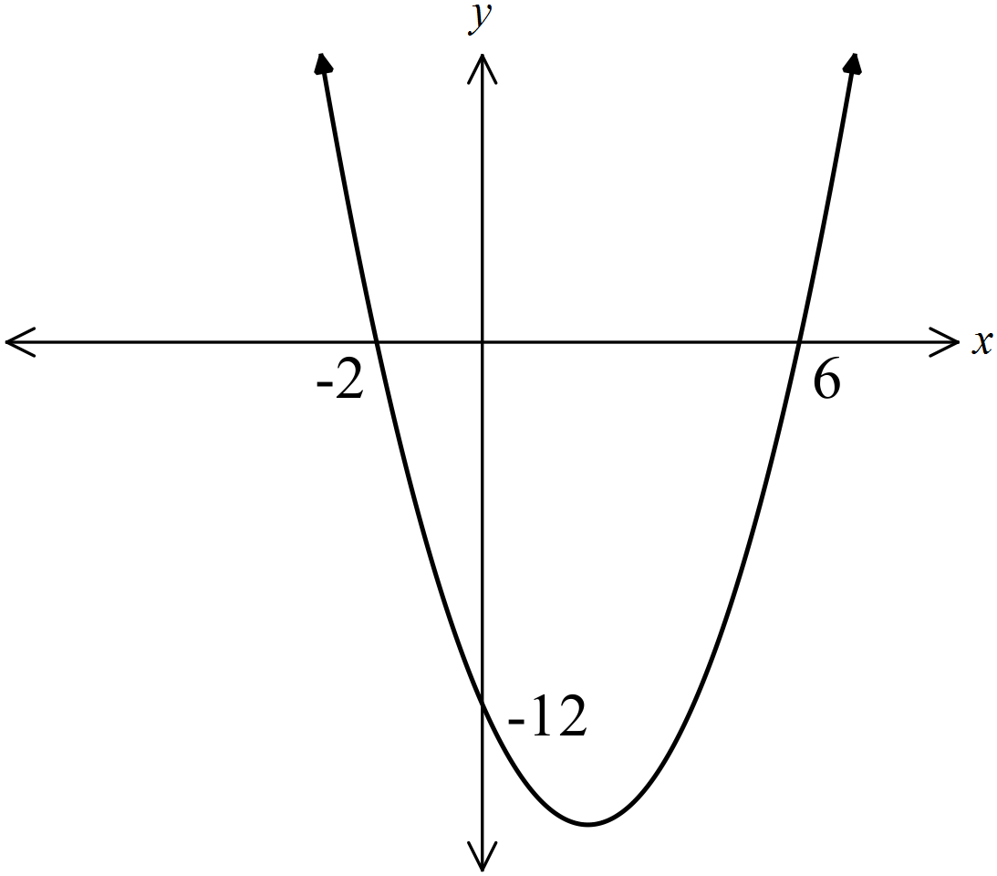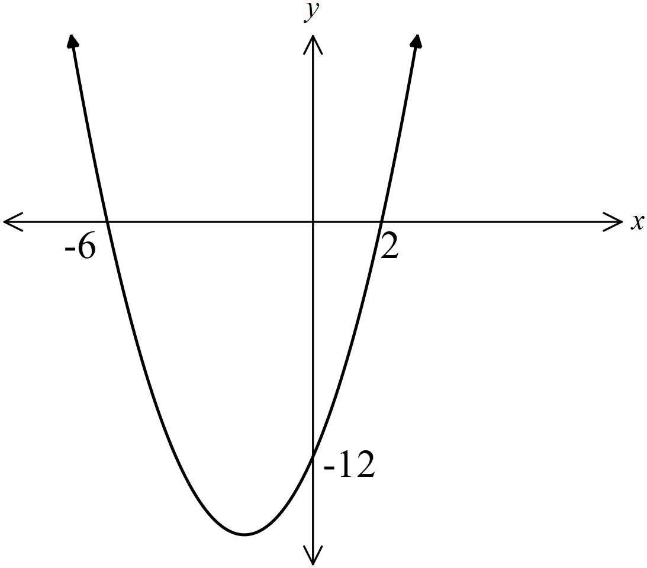A. B.

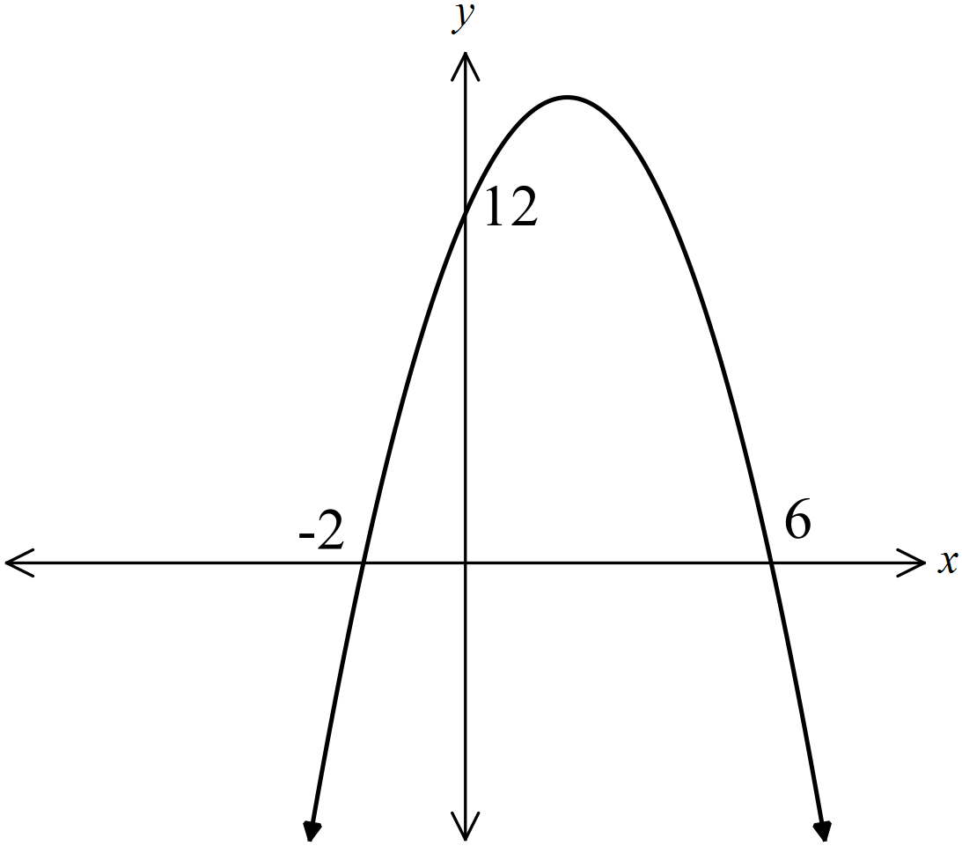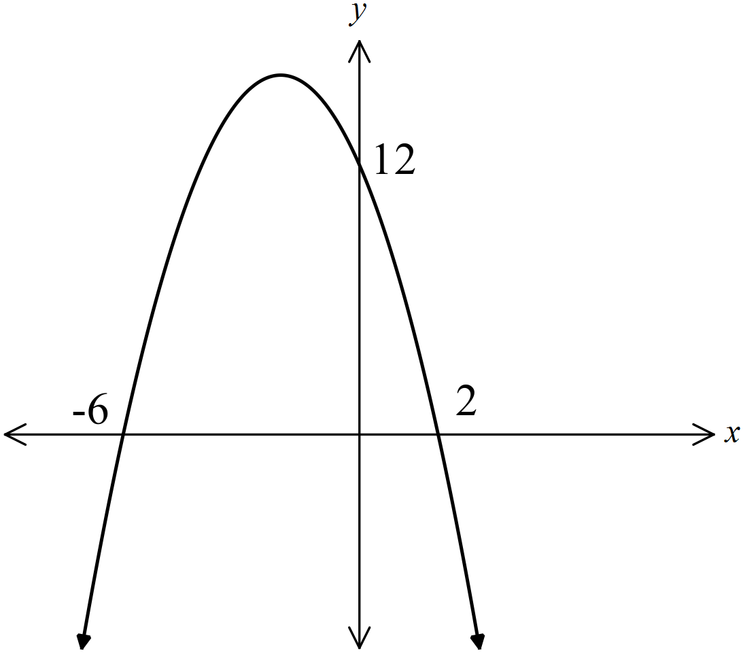 C. D.

The point A (2,10) lies on the curve shown on the graph below.
Which equation could describe the relationship between x and y on the curve?
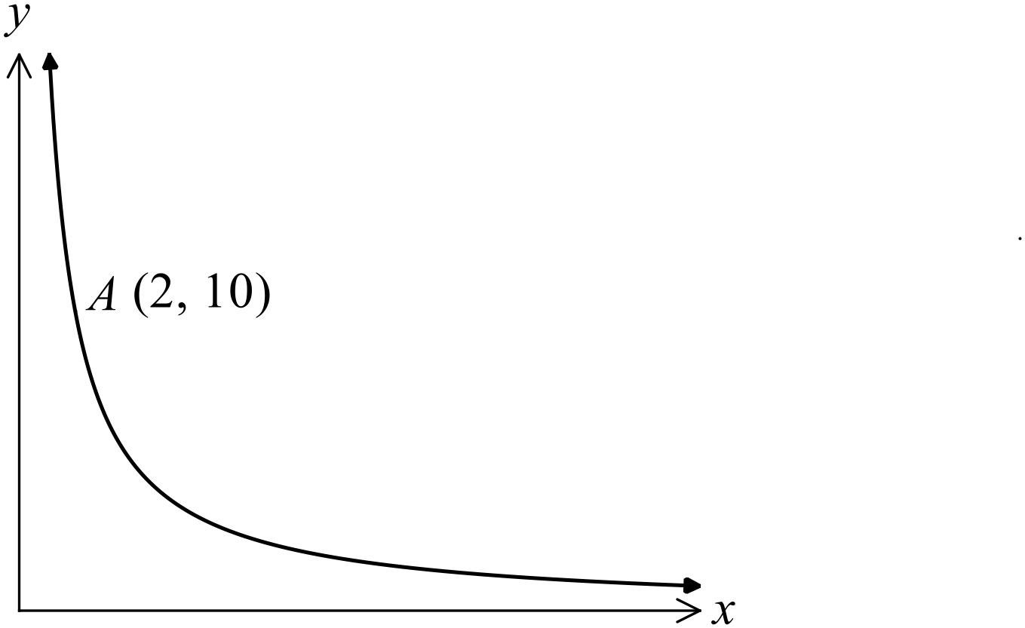

A. 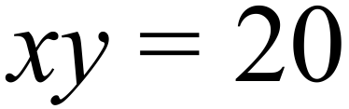 B. 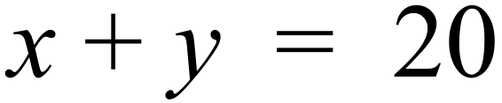
C. 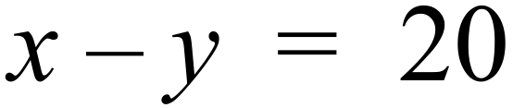 D. 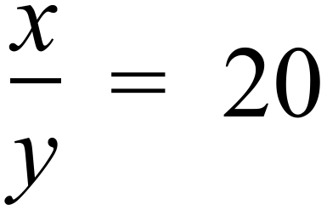
One hundred fans are surveyed at a footy match and asked which of the two teams playing they think will win.
The results are shown in the two way table.

 | Male | Female | Total
Bulldogs | 26 | 14
Tigers | 32 | 28
Total

If one female fan is chosen at random, what is the probability that they think the Tigers will win?

A. 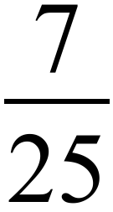 B. 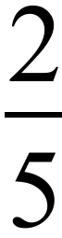 C. D. 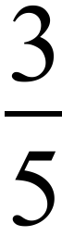
The Venn diagram shows the ingredients in the recipes in Emma’s recipe book.
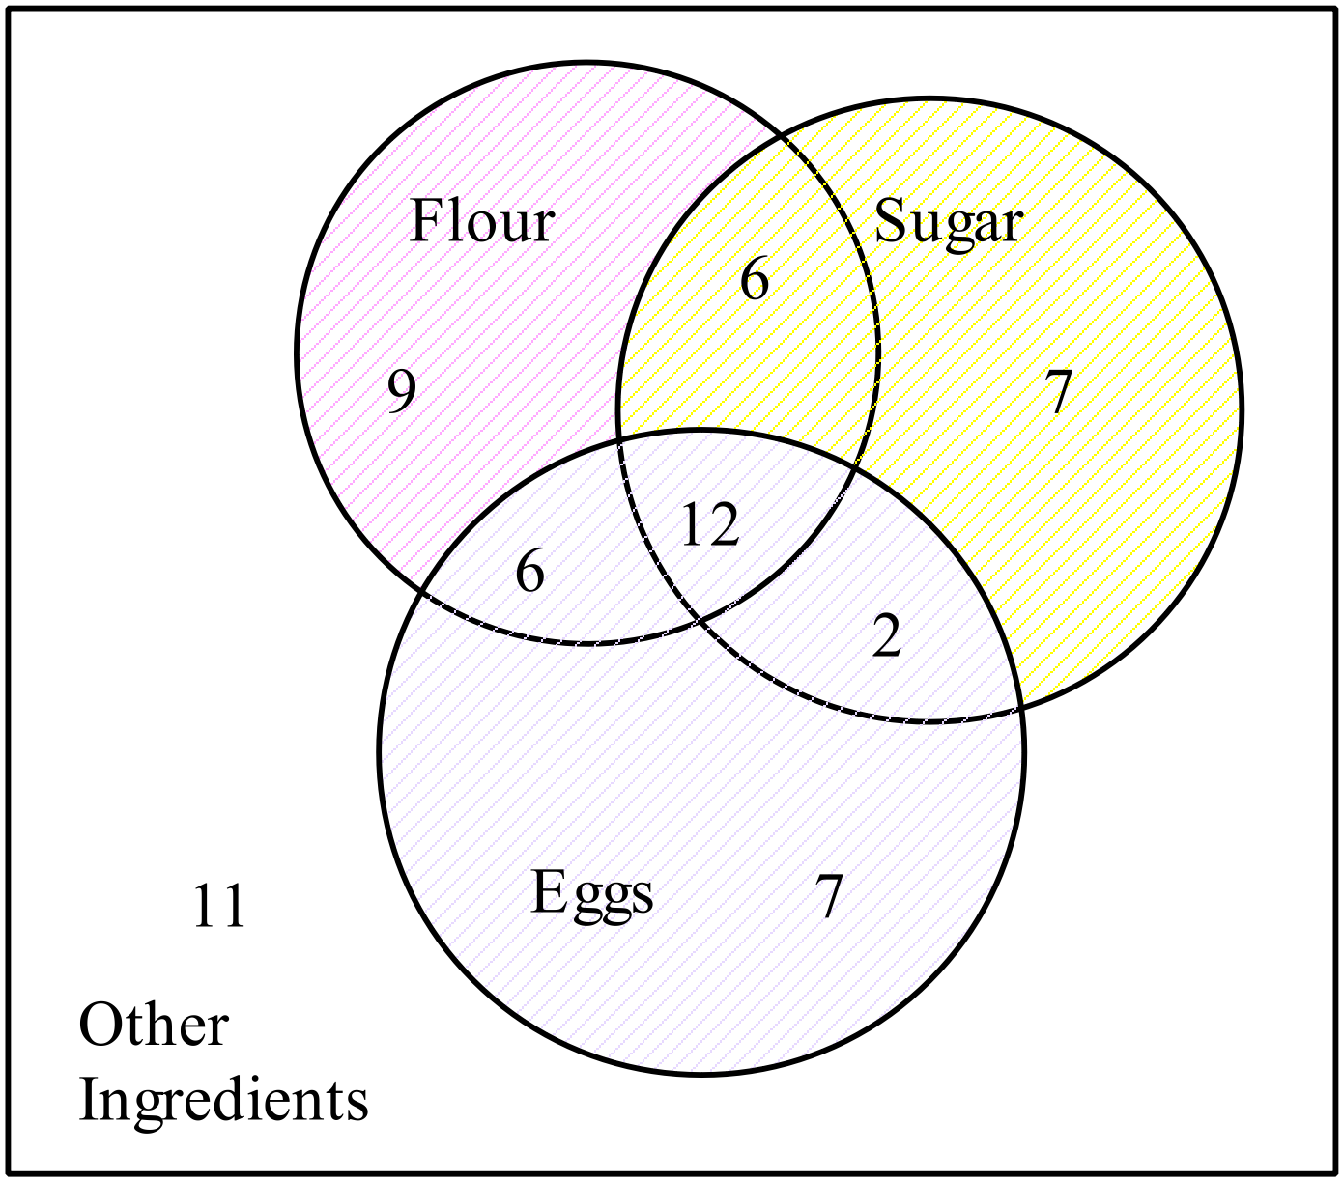

If a recipe is chosen at random, what is the probability that it contains both flour and sugar?
A. 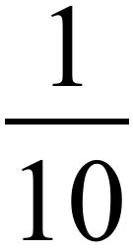 B. 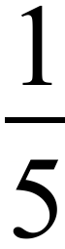 C. 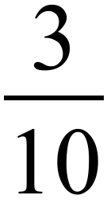 D.
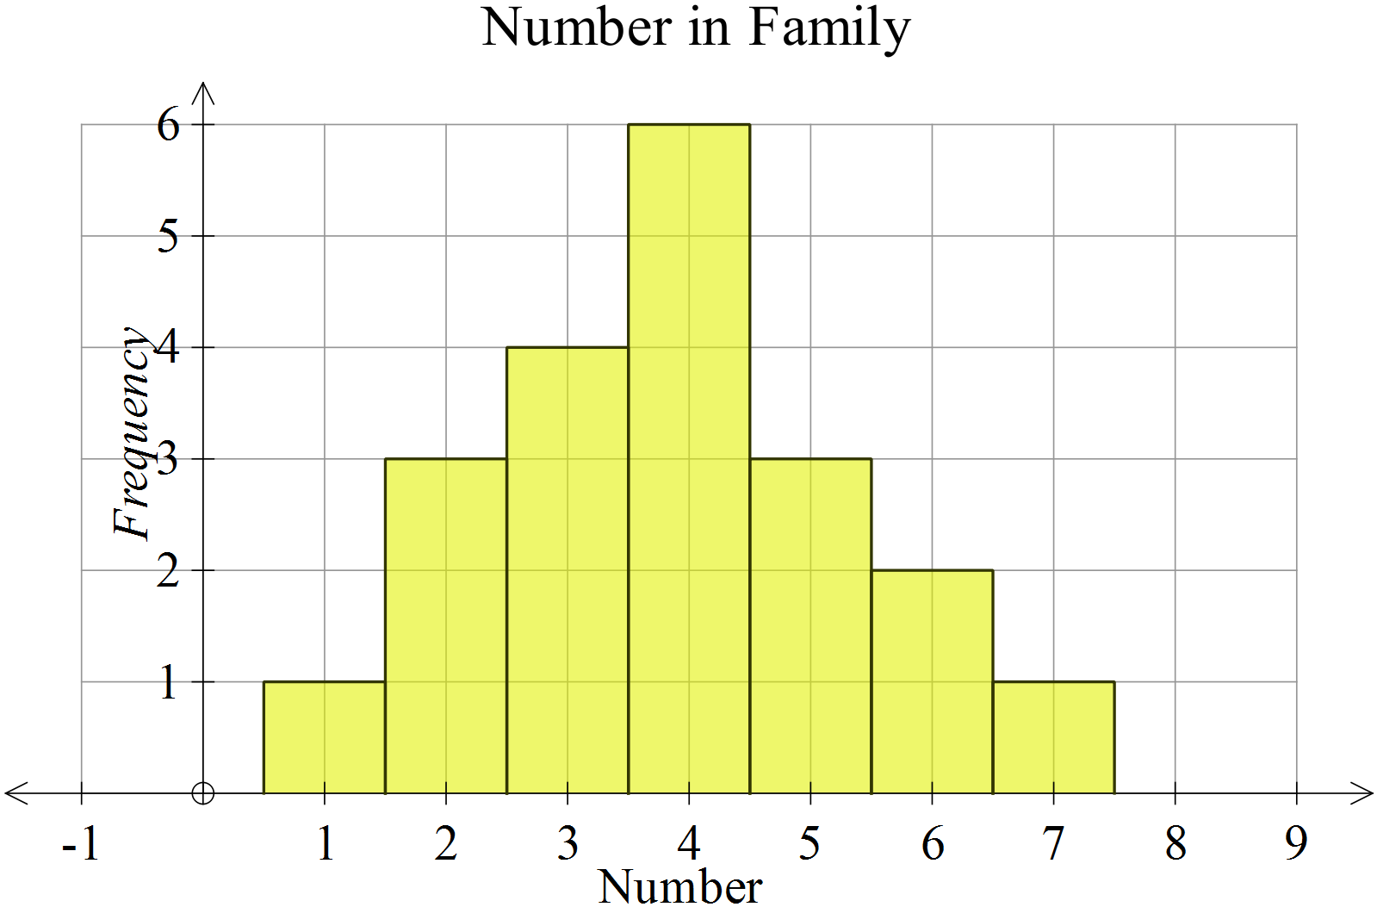What is the mean and population standard deviation of the data shown in the histogram?

A.
B.
C.
D.

Which of the box plots below shows a negatively skewed data distribution?
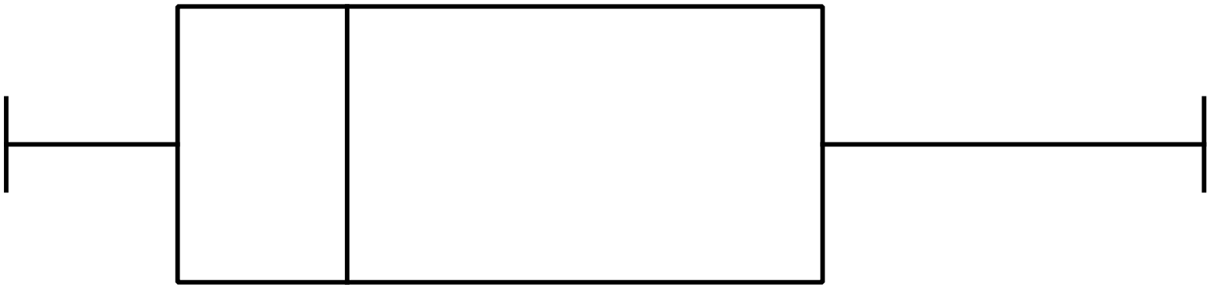
A.

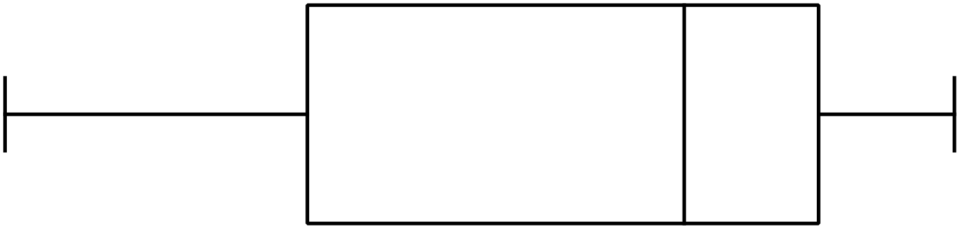 B.

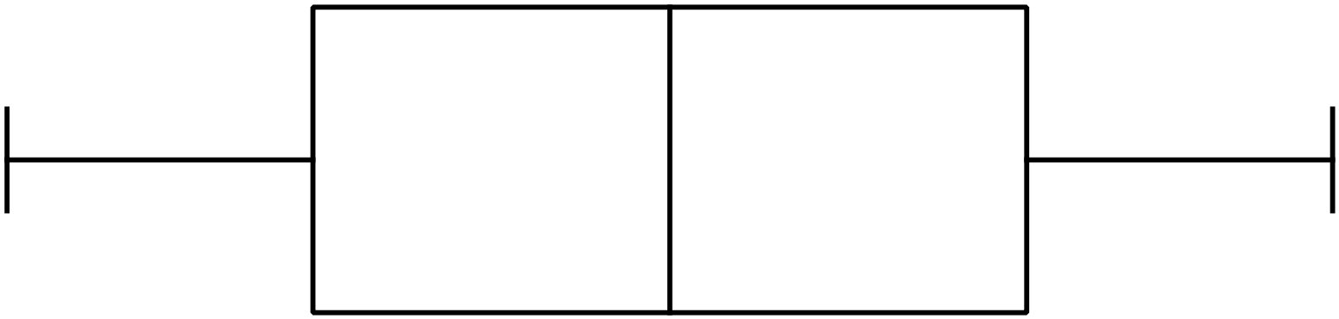
C.

D. 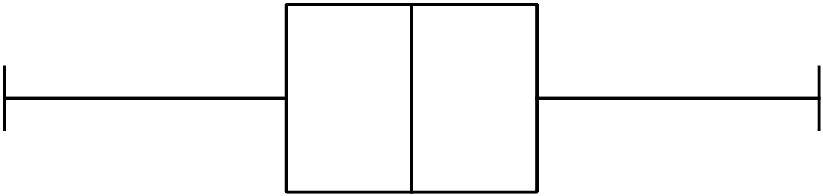

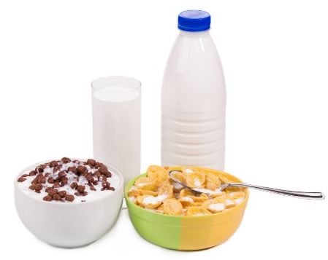
Two brands of breakfast cereal both claim to contain 15 grams of dietary fibre per 100 grams.
A sample of 50 packs of each of the cereals are tested for the amount of dietary fibre per 100 grams.
Some of the statistical results are shown below.

Measure | Brand A | Brand B
Mean amount of fibre | 15.1 | 15.0
Standard deviation | 1.5 | 0.5
Median amount of fibre | 15.2 | 14.9
Interquartile range | 3.6 | 1.6
Shape of distribution | Skewed | Symmetrical
Which is not true?
A. Both brands have an average amount of fibre which is 15 grams or more.
B. Brand A would have the middle 50% of its packets within a 3.6 gram range.
C. Brand B would have 25% of its packets with more than 15.7 grams of fibre.
D. Brand B is less consistent in achieving amounts of fibre which are close to their claim.
End of Section 2 Part A

Section 2  Part B  Longer Answer Section |  | Name : _______________________________
 |  | Class/Teacher___________________________
Write all working and answers in the spaces provided on this examination paper.
Calculators are allowed for this section.

 |  | Marks
76. | - Simplify 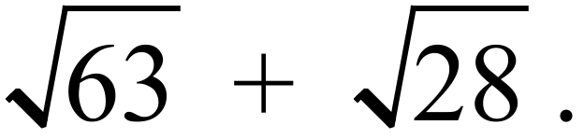  ………………………………………………………………………………………………  ………………………………………………………………………………………………. | 1
 | - Write 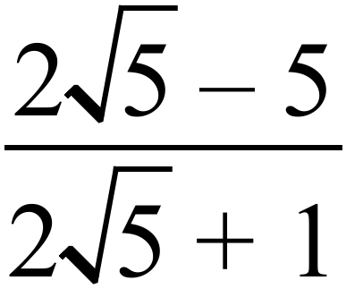 as a surd fraction with a rational denominator.  ………………………………………………………………………………………………  ………………………………………………………………………………………………  ………………………………………………………………………………………………. | 2
77. | 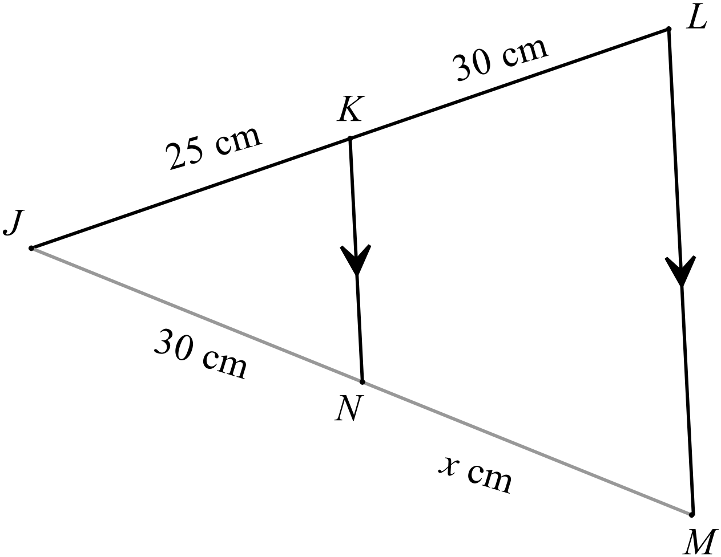In the diagram KN || LM, KL = JN = 30 cm and JK = 25 cm. | 2
Calculate the length of MN.
………………………………………………………………………………………………

……………………………………………………………………………………………….

………………………………………………………………………………………………

……………………………………………………………………………………………….

78. | 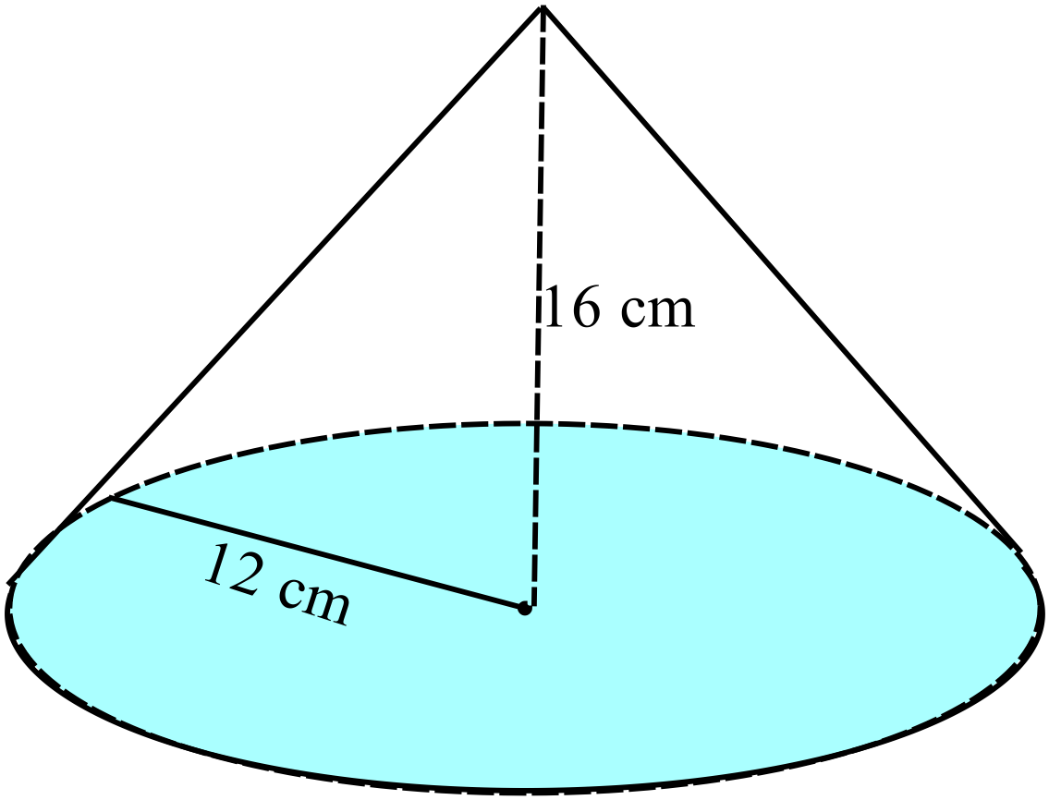The cone shown has a base radius of 12 cm and a perpendicular height of 16 cm.
 | Find the surface area of the cone.  ………………………………………………………………………………………………  ………………………………………………………………………………………………  ………………………………………………………………………………………………. | 2
79. | Express 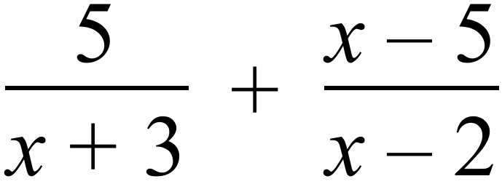 as a single algebraic fraction in simplest form.  ………………………………………………………………………………………………  ……………………………………………………………………………………………….  ………………………………………………………………………………………………  ………………………………………………………………………………………………. | 2
80. | 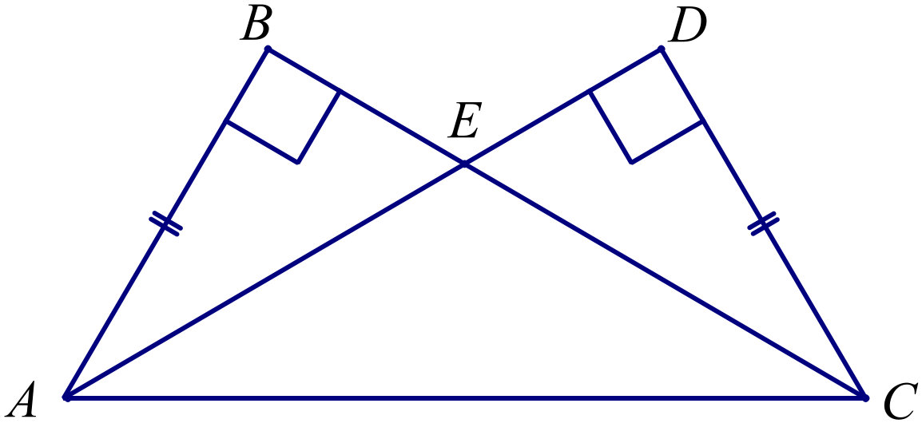
 | (a) Prove that 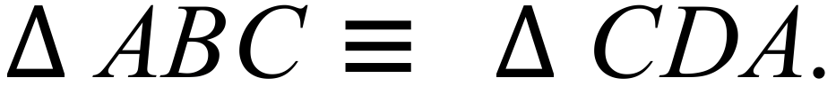  ………………………………………………………………………………………………  ……………………………………………………………………………………………….  ………………………………………………………………………………………………  ………………………………………………………………………………………………. | 2
 | (b) Hence prove that 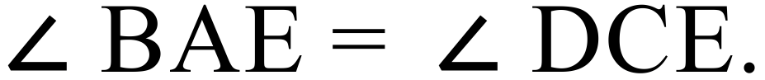  ……………………………………………………………………………………………….  ………………………………………………………………………………………………  ………………………………………………………………………………………………. | 1
81. | A tower CD stands on level ground.  Ava stands at A and measures the angle of elevation of the top of the tower to be 29º.  She then walks 50 m toward the tower to B and measures the angle of elevation of the top of the tower to be 51º.  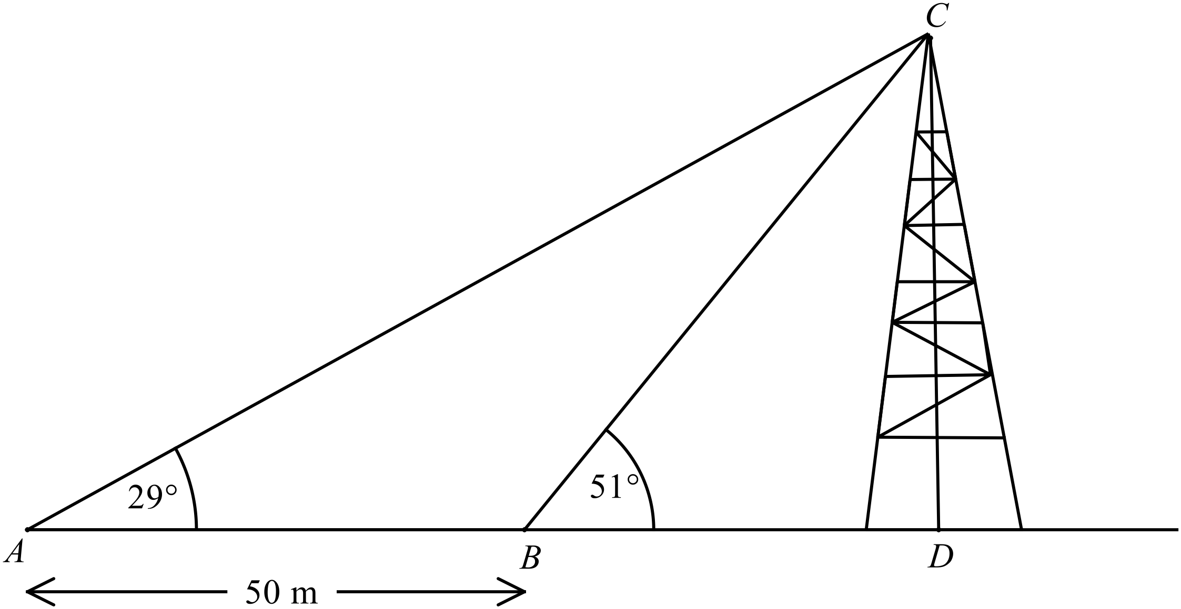
 | (a) Calculate the distance BC.  ………………………………………………………………………………………………  ………………………………………………………………………………………………  ………………………………………………………………………………………………. | 1
 | (b) Hence find the height of the tower CD.  ………………………………………………………………………………………………  ………………………………………………………………………………………………. | 1
82. | Karim measures the lengths of the three stages of a triangular hiking course.  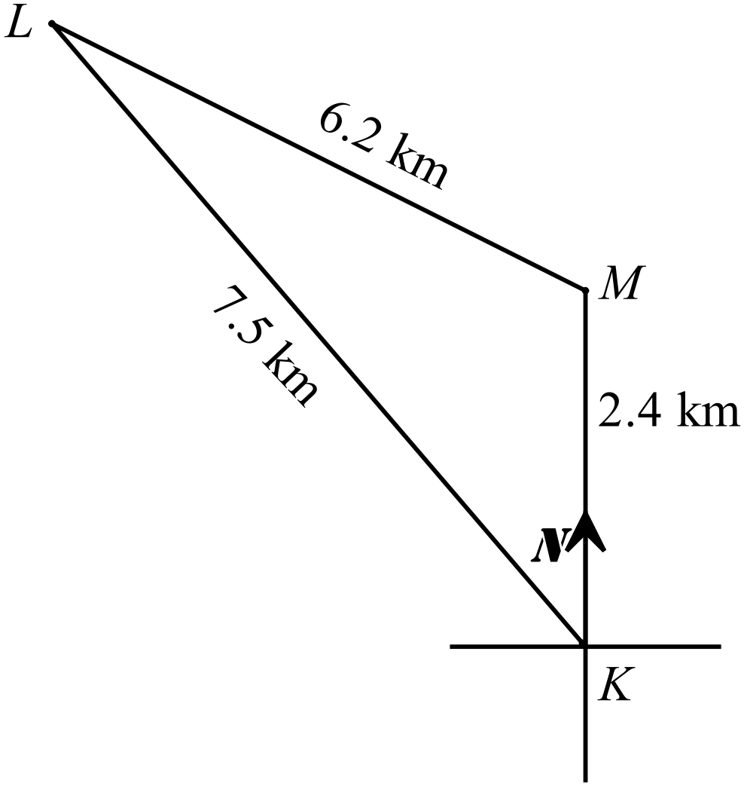M is due north of K. | 2
What is the bearing of L from K?

………………………………………………………………………………………………

………………………………………………………………………………………………

………………………………………………………………………………………………

……………………………………………………………………………………………….
83. | (a) Find the points where the curve 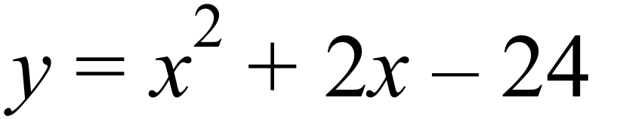 crosses the x axis  ………………………………………………………………………………………………  ………………………………………………………………………………………………. | 1
 | (b) What is the least value of y on the graph of 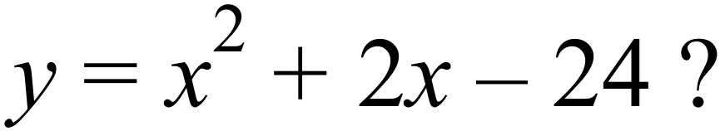………………………………………………………………………………………………  ………………………………………………………………………………………………. | 1
 | (c) Draw a sketch graph of on the axes below.  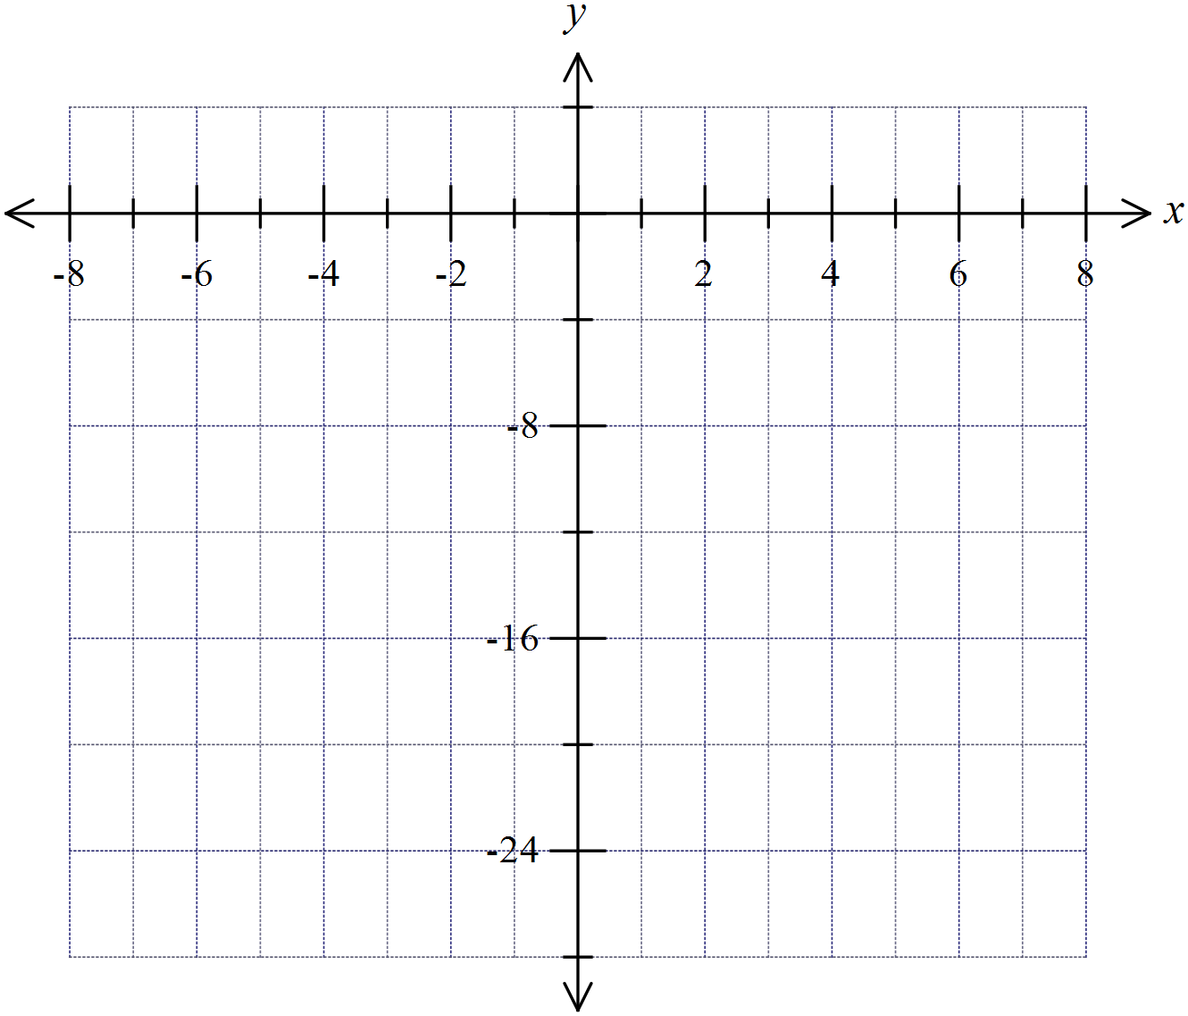 | 1
84. | Ariel rolls two dice as a part of a board game.  She uses the table below to record the possible outcomes.  
   | 1 | 2 | 3 | 4 | 5 | 6
  1
  2
  3 |  | 3, 2
  4
  5
  6
 | (a) Complete the table. | 1
 | (b) What is the probability that the numbers on the two dice have a product of 12 ?  ………………………………………………………………………………………………  ………………………………………………………………………………………………. | 1
85. | The hand spans (in cm) of a group of 25 people were measured. The results are shown in the dot plot below.  Hand Span (cm)
   |  |  |  |  | ●
   |  |  |  |  | ● | ● | ●
   |  |  |  |  | ● | ● | ● | ●
   |  |  |  | ● | ● | ● | ● | ● | ● | ●
   |  |  | ● | ● | ● | ● | ● | ● | ● | ● | ● |  |  | ●
   |  |  | 16 | 17 | 18 | 19 | 20 | 21 | 22 | 23 | 24 | 25 | 26 | 27
 | (a) Calculate the mean and standard deviation of the data.  ………………………………………………………………………………………………  ………………………………………………………………………………………………. | 2
 | (b) Describe the data in terms of the shape of the distribution and whether there are any outliers.  ………………………………………………………………………………………………  ………………………………………………………………………………………………. | 1
 | End of Exam

High School
2014 Yearly Exam
Advanced Mathematics Course
Multiple Choice Section Answer Sheet
Name ________________________________ Teacher ________________________

Completely fill the response oval representing the most correct answer.

26. A B C D
27. A B C D
28. A B C D
29. A B C D
30. A B C D
31. A B C D
32. A B C D
33. A B C D
34. A B C D
35. A B C D
36. A B C D
37. A B C D
38. A B C D
39. A B C D
40. A B C D
41. A B C D
42. A B C D
43. A B C D
44. A B C D
45. A B C D
46. A B C D
47. A B C D
48. A B C D
49. A B C D
50. A B C D

51. A B C D
52. A B C D
53. A B C D
54. A B C D
55. A B C D
56. A B C D
57. A B C D
58. A B C D
59. A B C D
60. A B C D
61. A B C D
62. A B C D
63. A B C D
64. A B C D
65. A B C D
66. A B C D
67. A B C D
68. A B C D
69. A B C D
70. A B C D
71. A B C D
72. A B C D
73. A B C D
74. A B C D
75. A B C D

